Online Legal Research with Fastcase®

CONTENTS

1| ELECTRONIC SEARCH BASICS

2| BOOLEAN SEARCHING

3| ORGANIZATION OF MATERIALS

4| COMPOSING SEARCHES

5| FASTCASE® RELEVANCE SCORE

6| INTEGRATED CITATION ANALYSIS

7| THE INTERACTIVE TIMELINE

8| DYNAMIC AND PERSONAL INTERFACE

APPENDIX A| A LITTLE BIT ABOUT US

APPENDIX B| SAMPLE RESEARCH EXERCISES

1| ELECTRONIC SEARCH BASICS

a. Contents and Structure
Electronic research resources can be structured in a number of ways—they vary from full text databases, to indexes, to something in between. Fastcase is a full text database enhanced with indexes in certain areas. Fastcase also has an important field searching capability—you can retrieve documents by citation using a Citation Lookup search. A Citation Lookup search is a field search of the citation field associated with a document.
b. Linguistic Challenges
One of the unique challenges of electronic research, particularly with respect to full text searching, is that as a researcher, you are generally searching for a concept rather than a particular phrase or set of words. But full text searches are based on words, not concepts. As a result, it takes some practice—trial and error is best—to translate concepts into effective search terms. It helps to keep two specific issues in mind: synonymy and ambiguity.
Synonymy means that there are many words that can express the same concept. Thus, in order to craft a comprehensive search, take a moment to think about various ways to express the concept you are researching.
Ambiguity is the other side of the coin: any given set of words can also express more than one concept. There are a number of ways to deal with ambiguity in the research process. For example, try adding more search terms to eliminate false positives or irrelevant search results. There may also be other ways to narrow down results, for example by focusing on a particular jurisdiction or time period. Fastcase gives you powerful tools to sort and filter results in a number of ways including relevance, decision date, case name, jurisdiction, and court hierarchy.
c. Search Methods
There are two basic approaches to searching for electronic information: searching by subject or by keyword. One familiar example of a subject-based search is the traditional library card catalog. In the legal research arena, West Thompson’s Key Number system is a commonly used subject-based search tool. When it comes to searching by keyword, it is not difficult to think of an example: Google’s internet search made keyword searching a part of everyday life.
Subject Approach:
Subject-based searches rely on a top-down system of categorization. Someone (or something, like a software program) must define subject categories and decide how to organize data into those categories. This type of system has some clear advantages and disadvantages.
On the plus side, some important work has already been done for you. Someone has already digested the electronic data and organized it by subject. As a result you may be able to locate a resource quickly that would have been difficult to find any other way. For example, if you were searching a database of book titles for a novel set in Spain, you may very well find “The Blind Man of Seville” by Robert Wilson since the title contains a reference to the Spanish city of Seville. It is unlikely, however, that you will come across “The Shadow of the Wind” by Carlos Ruiz Zafon, set in Barcelona. In this example, a subject-based index would be helpful.
On the other hand, with subject-based searches, you are inherently relying on someone else’s system of categorization. This introduces the possibility that there are errors in the way that the information has been categorized or that the system of categorization is counter to the way you would organize the same information in your own mind.
Keyword Approach:
Keyword searches work a bit differently. When you search by keyword, you are searching for any instance of a search term in the electronic data. Depending on the way the electronic data is indexed, this may mean that you can search for terms within certain fields such as title, subject, author, etc. or you may be able to search the entire text (or .full text.) of the electronic data.
Searching by keyword has the advantage of being both precise and flexible: you can search for all electronic data containing the term(s) that you specify and there is no need to rely on pre-determined system of categorization. This advantage can also be seen as a disadvantage because it means you have to do a little more work. You must select keywords that accurately describe the concept or topic that you want to research. While selecting appropriate keywords is not difficult, it can take some practice.
Fastcase was designed using the latter-approach: keyword searching. On Fastcase, the full text of our case law, statutes, regulations, court rules, and constitutions are all fully searchable by keyword; these resources have not been assigned subject categories. You will find suggestions on how to construct effective keyword searches in Chapters 2 and 4.

2| BOOLEAN SEARCHING

By now most of us have experienced Boolean search logic in some form. Many online databases incorporate Boolean search logic, including traditional legal research services like Lexis-Nexis and Westlaw. Fastcase supports Boolean search logic as well. The beauty of Boolean search logic is that it allows you to combine multiple search terms together in ways that can help you more precisely express the concept or the topic you wish to research.
a. Boolean Operators
Boolean search logic is accomplished using a series of symbols or .operators. Fastcase’s search protocol uses the six common Boolean operators described below:
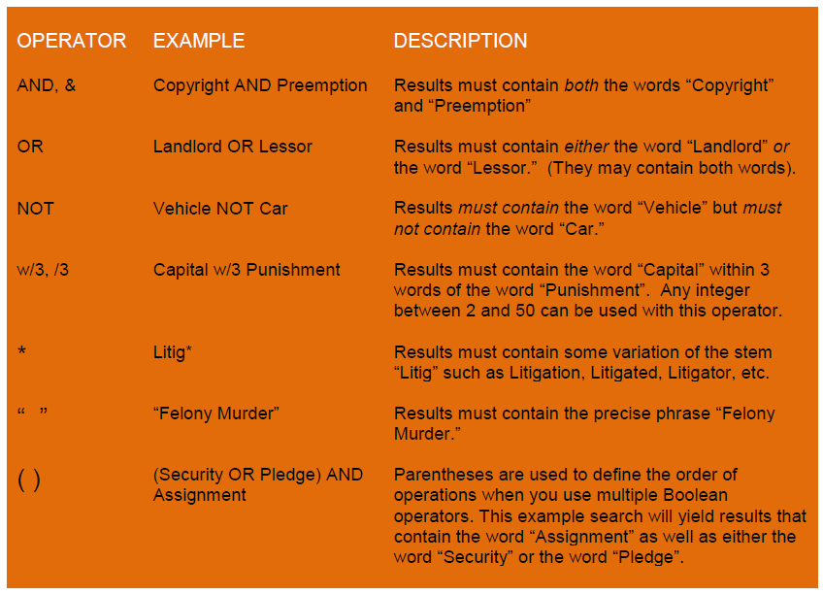
b. Plurals
Some search engines automatically search for both the singular and regular plural form of words when you enter the singular form. Fastcase automatically searches for regular plurals when you use natural language search (but not when you search by keyword).
c. Order of Operations
Every search engine has its own default .order of operations., the order in which it processes a query with multiple Boolean operators if you do not explicitly set the order using parentheses. In the absence of parentheses, Fastcase will parse your search sequentially from left to right.

3| ORGANIZATION OF MATERIALS

On Fastcase, documents are organized into five separate buckets according to the type of law. There is a bucket for case law, one for statutes, etc. Currently Fastcase contains the following 5 types of primary law documents:
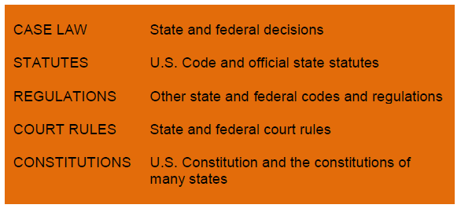
a. Quick Caselaw search
Begin your search by selecting the type of document you would like to search. All five document types are listed on the Search drop-down menu.
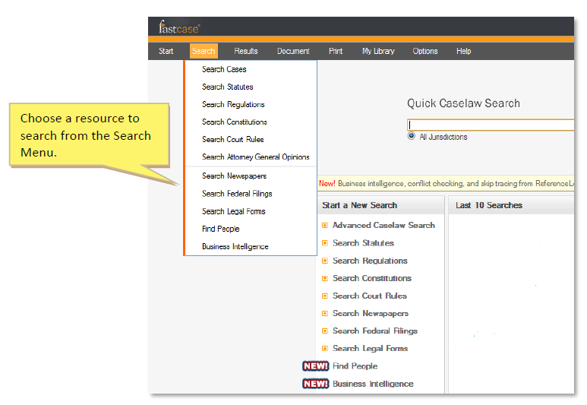
b. Narrowing Options
In Chapters 1, and 2, we talked about the fact that Fastcase is designed using the keyword search model allowing you to search the full text of each document for the presence of search terms that you define. Fastcase also allows you to narrow your search by choosing a specific slice of each database to apply your search terms to. You can also narrow by jurisdiction, by date range, or a combination of the two.
Jurisdiction:
Fastcase allows users to limit searches to documents from a particular jurisdiction. The Advanced Caselaw Search interface has a simple and stream-lined jurisdiction selection tool. Users can choose from five meta-categories of jurisdictions (1. All jurisdictions, 2. All Federal Appellate, 3. All State, 4. All District Courts, or 5. All Bankruptcy Courts). Selecting the last option on the list, Individual Jurisdictions, allows users to create a customized list of jurisdictions by mixing and matching individual courts from any of these categories.
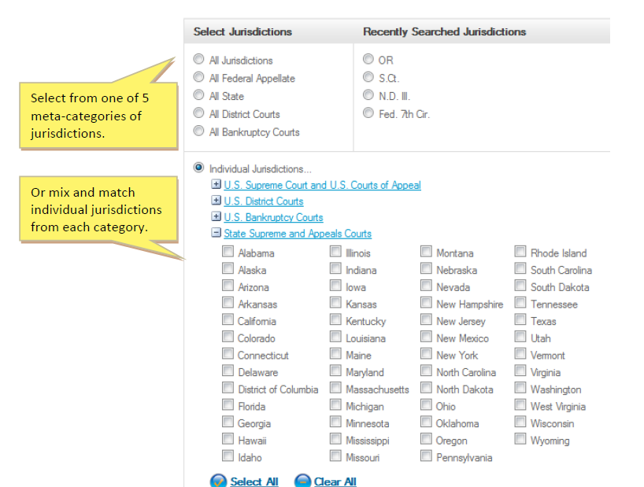
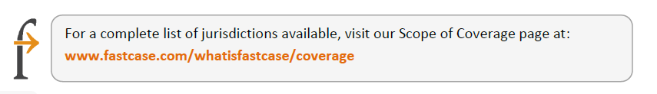
Selecting a jurisdiction works a little bit differently with for other types of documents on Fastcase. When you initiate a search for Statutes, Regulations, Court Rules or Constitutions, by selecting the appropriate category from the search menu, you will be taken to a screen with an alphabetical list of jurisdictions to choose from.
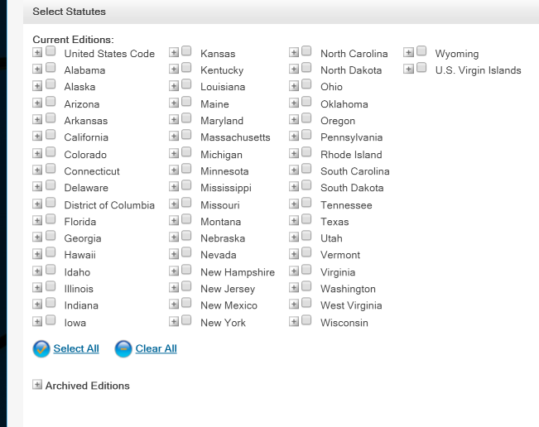
Search Statutes
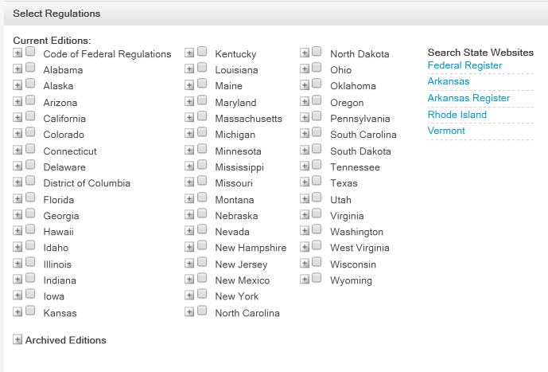
Search Regulations
From here, you can select the particular jurisdiction (or if Fastcase has more than one type of resource within that jurisdiction, you can select a particular resource) by clicking on it. Now when you perform a search, your search will retrieve documents within this particular resource.
Date Range:

Choosing a date range for your case law search is easy. Just select a month and year from the date field windows under the Library selection panel on the Advanced Search page. Note that our default settings are a start date of January Before 1925 and an end date of the current month (which adjusts automatically).
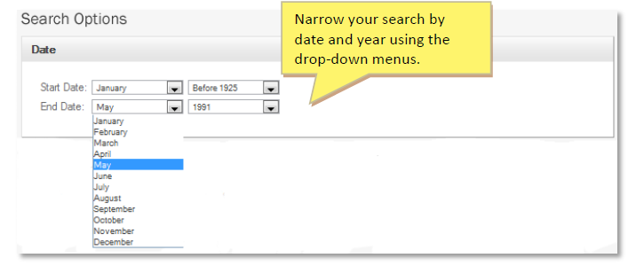

4| COMPOSING SEARCHES

a. Citation Lookup
Case Law:
So far, we have focused on Fastcase’s full-text keyword searching capabilities, but as discussed in Chapter 1, Fastcase does have an important field search capability as well. You can pull up a case by its official reporter citation. At Fastcase we call this a “Citation Lookup”. To perform a Citation Lookup you need only enter the reporter volume number, the reporter abbreviation, and the first page of the case.

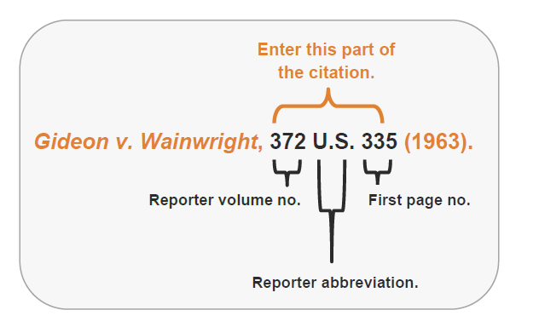

Fastcase’s search engines are fault tolerant, so even if you omit some of the periods in the reporter citation, the search engine will still retrieve your case.
Other Documents:

Fastcase allows you to retrieve other documents (such as statutes, codes, regulations, etc.) by citation as well. Just remember to ensure that the library you have selected would contain that citation.
b. Keyword (Boolean) Search
Searching by Keyword using Boolean operators is a powerful way to search for electronic information. Here are some strategies for formulating effective searches.
Identify Issues:

Before diving into an electronic search, it is a good idea to spend some time identifying the issues or concepts that you are seeking information about. Until you have nailed down these issues or concepts, it will be difficult to craft an effective search. Often this means learning the terminology that courts use to discuss your issue or identifying the relevant legal doctrine. Conducting a bit of background research using treatises, casebooks, and law review articles can be tremendously helpful in this process. Another approach is to conduct a few natural language searches to see if you can find some authority that can provide some of this background.
Brainstorm Search Terms:
After identifying the issues or concepts that you wish to research, the next step is to brainstorm keywords that would likely to appear in a judicial decision or other document addressing these issues. Remember to consider synonyms, antonyms and related legal theories or concepts.
For example if you are researching the legality of an officer’s search of an automobile at a traffic stop, you may want to think about including synonyms of automobile such as “vehicle” and “car”. And if you can identify a legal doctrine that applies to the issue, that can be helpful as well. In this example, “Fourth Amendment” would be a useful search term because that is the primary source of law with respect to government searches.
Relate Terms Using Boolean Operators:
Once you have a list of keywords, the next step is to construct a search query by arranging the keywords into issues and concepts using Boolean operators. See Chapter 2 for descriptions of each operator and examples of search syntax using the operators.
- The basic AND, OR, and NOT operators allow you to determine whether multiple search terms will appear in a document.
- The proximity operator w/n (where n is a whole number between 2 and 50), allows you to determine how far apart multiple search terms will appear in a document.
- The wildcard operator * allows you to search for any form of a word with a particular stem.
- Putting search terms in quotation marks “ ” allows you to search for a precise phrase.
- Use parentheses ( ) to specify the order of operations. *
Evaluate Search and Search Results:
After choosing your search terms and connectors, take a moment to evaluate your search before you fire off your query. In particular, ask yourself, could my search be simplified? We all have a tendency to write searches that are unnecessarily long and complex. Long searches are likely to include redundant or imprecise terms that could cause you to miss results on your topic.
Once you have performed your search, scan the search results and assess whether you need to modify your search.
- Are your results too narrow? Try adding synonyms or removing redundant language.
- Are your results too broad? Try adding additional terms or filtering irrelevant results with the “NOT” connector.
c. Natural Language Search
In addition to searching for documents by citation or by keyword using Boolean operators, Fastcase users also have the option of performing a natural language search. This type of search allows you to describe a concept or topic the way you would in plain English without the need for Boolean operators. Each time you search, the search engine will retrieve bottomless documents with the highest relevance scores based on the search terms you selected.
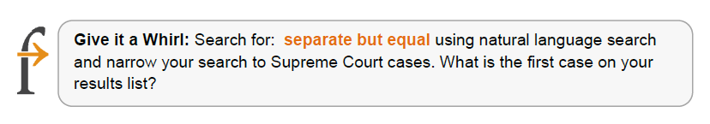
While dispensing with Boolean operators may seem like a great benefit, the flip-side is that a natural language search is less precise than an ordinary keyword search.
Natural language search is a great resource for researchers who do not have a legal background or when you simply do not know where to start. If you are delving into a new area of the law and you are having trouble brainstorming search terms because you are unfamiliar with the topic you are researching, a natural language search can get you headed in the right direction. On the other hand, researchers who are familiar with legal terminology and have some background in the topic they are researching will be able to retrieve documents more efficiently and precisely using ordinary Keyword searches.

5| FASTCASE® RELEVANCE SCORE

Each document in a set of search results is assigned a Fastcase Relevance score based on the search terms used in the query. This relevance score is displayed in the far left-hand column on the results page under the heading “Relevance”.
The purpose of the Fastcase® Relevance score is to give you information about which documents on your list of search results are more likely to discuss the topic you have in mind. The higher the Fastcase® Relevance score, the greater the likelihood that a document contains a discussion of the topic.
The score is calculated by measuring four properties of each document in the search results: numerosity, proximity, density and diversity.
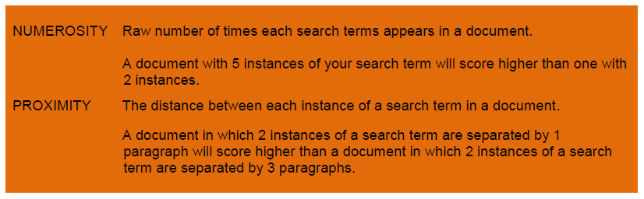
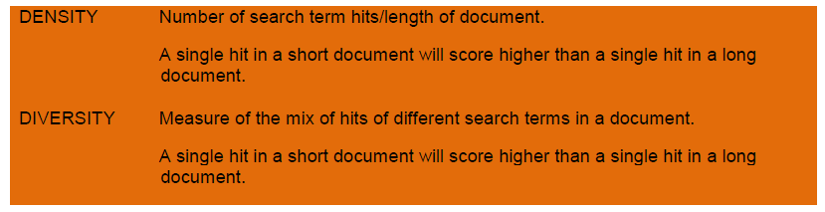
By default, your search results will be displayed in the relevance-score order (meaning 100% relevance scores at the top of the list) on the results page. If you have chosen a different sorting order and want to re-sort you search results according to their Fastcase Relevance Score, simply click the Relevance heading on the Results page.
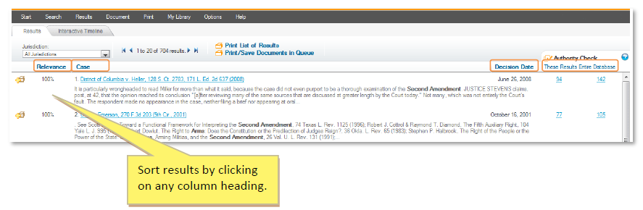

6| INTEGRATED CITATION ANALYSIS
a. Authority Check Overview
One of the biggest advantages of online legal research tools over hardcopy resources is the ability to hyperlink to internally cited references and later citing references. Effective online legal research tools also give researchers the ability to gather and analyze data about the nature of links and relationships between cases.
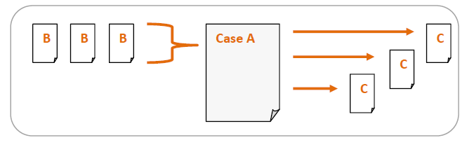
Identifying and reading later citing references can help a researcher determine whether a particular case is still good law. Examining internally cited references can help to provide context for a decision and even provide clues about the court’s decision-making process. Both later citing references and internally cited references can lead a researcher to additional authority for a particular proposition or point of law.
At Fastcase, we have developed a powerful citation analysis tool called, “Authority Check” that puts a vast quantity of citation analysis at your fingertips. There are countless ways in which you can use Authority Check to enhance and expedite your legal research. In its simplest application, Authority Check provides hyperlinks to internally cited references within a case.
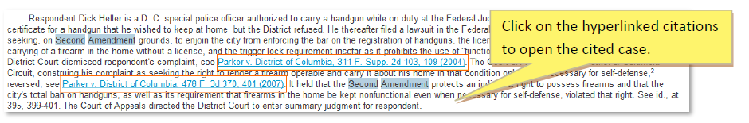

Two other common applications of Authority Check are identifying later citing cases and identifying authoritative or seminal cases.
b. Identifying Later Citing Cases
Identify later citing cases using an Authority Check Report. To generate the report for a case, click on the blue number under the Authority Check heading when viewing the case. The Authority Check Report for the case will open in a new tab or window in your browser.
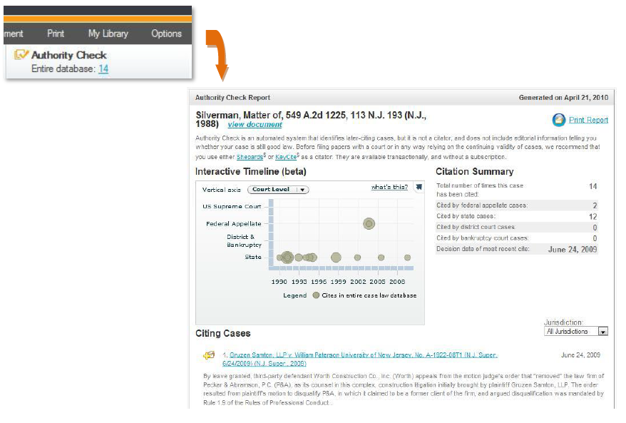
The report is chock-full of information about the later citing cases. On the top of the report, you will see a break-down of which types of jurisdictions are citing to the case and if there are any negative citations.
Underneath the jurisdiction break down, you will see the interactive timeline. See chapter 7 for more details on the interactive timeline.
A bit further down the page under the interactive timeline, you will see a chronological hyperlinked list of cases in the Fastcase database that cite to the primary case you researching.
c. Identifying Frequently Cited Cases
Not all sources of law are created equal and certain documents carry more weight with the court. The weight of authority of a particular source of law can depend on a number of different factors including the type of document, the author of the document, when the document was created, the context in which the document is being offered for authority, and even how frequently the document has been relied on in the past.
The official reporter citation of a written decision offers many clues about the weight of authority. You can determine which court issued the decision and when it was issued. A quick glance at the beginning of a written decision will also tell you who authored the decision. Authority Check brings another piece of the puzzle to the surface–the number of times a decision has been cited by subsequent cases. This number is displayed in the right column on the results page under the heading “Authority Check”.
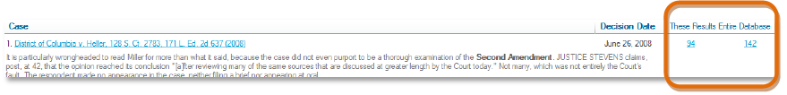
Click on the words “Entire Database” to sort your search results and bring the most frequently cited cases to the top of the list. It is always a good idea—either at the outset of your research project or before you conclude—to sort your search results according to their Authority Check score and read the top 5, 10, or 15 most frequently cited cases. Chances are that your opponent and your judge will be familiar with these seminal cases and it behooves you to familiarize yourself as well.
You can take your citation analysis a step further by clicking on “These Results”. This will sort your search results according to how often each case is cited within the super-relevant set of other cases in the list of search results. By refining your citation analysis in this manner, you increase your chances that the cases at the top of the list are frequently cited with respect to the topic you are researching.
While the number of subsequent citations standing alone does not determine the authoritativeness of a decision, it can be an extremely helpful measure in evaluating whether a decision is authoritative. Indeed, the more frequently a decision is cited by subsequent cases, the more likely it is that a decision carries weight in the legal community. Combine citation analysis information with the Fastcase Relevance Score using the Interactive Timeline (discussed in Chapter 7) and you have a powerful visualization of the authoritativeness of a case.

7| THE INTERACTIVE TIMELINE

The Interactive Timeline is a powerful data visualization tool unique to Fastcase. By allowing you to view up to four different attributes of each case at a time, your search results jump off the page. The Interactive Timeline is chock-full of information and customization options. We will cover the fundamentals here.
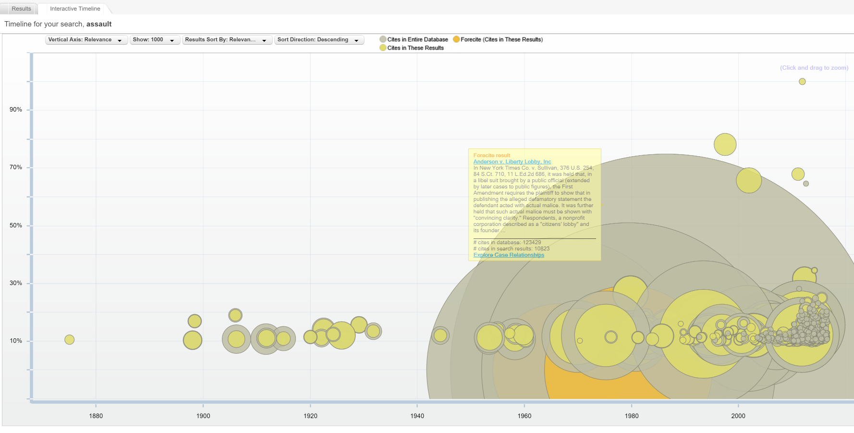
The interactive timeline automatically loads at the bottom of your results. The interactive timeline displays the results of your search so you can visually see the results of your search. To zoom in, click and drag your mouse over the segment of the timeline that you want to expand. To return to the overall timeline, click on “zoom out” in the upper right hand corner. To see further information about a case on the timeline, hover your mouse over the circle and Fastcase will display the case name, citation, number of times that the case has been cited, and a brief description of the case. To view that case, simply click on the blue hyperlink.
a. Reading the Interactive Timeline
Each case on your search results list will be represented by a gray circle. The diameter of the circle is determined by the number of times the case has been cited in the Fastcase database: the larger the diameter, the greater the number of subsequent citations. The smaller yellow diameter represents how many times each case has been cited within the given set of search results. Another way of thinking about this is the number of times the case has been cited by other cases containing the same search terms. The gray diameter represents the number of subsequent citations in the entire Fastcase database.
There are two basic formats for viewing the Interactive Timeline: Relevance View and Court Level View. In Relevance View, the vertical or Y-axis displays the Fastcase Relevance Score (a percentage between 0-100%) for each case in your search results. In Court Level View, it displays the type of the court (U.S. Supreme Court, Federal Appellate, District & Bankruptcy, or State) that issued each decision.
The horizontal or X-axis always displays the decision date. By default, the timeline will include the entire range of dates between the earliest case and the more recent case in your search results. You can zoom in on a narrower date range by dragging the slider underneath the timeline.
The Interactive Timeline will default to displaying up to 1000 search results at a time. You can choose to display more or fewer results using the filter at the top of the screen.
b. Identifying Authoritative Cases
By illustrating how relevant each case is based on your search terms, how many times each case has been cited by subsequent cases, the Interactive Timeline makes seminal and authoritative cases jump off the page. (By contrast, long lists of text search results – even when sorted well – only show one ranking at a time). For the best results, first make sure that you are in Relevance View. Then look for cases with large diameters that appear towards to the top of the page because frequently cited cases with high relevance scores are the most likely to be authoritative.
Here is an illustrative example: if you perform a keyword search for “second amendment” AND arms, you will see something that looks like this:
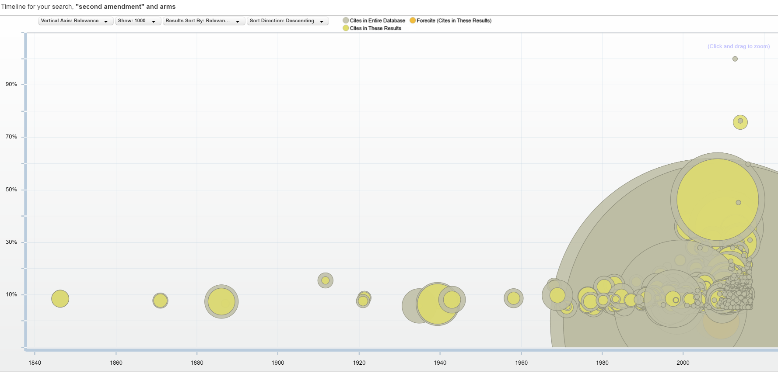
It is easy to spot authoritative cases on the timeline – look for circles with large yellow and gray diameters as well as circles that appear higher up than other contemporaneous cases.
The Interactive Timeline can also illustrate trends in the law. For example, the timeline above illustrates the nearly 70-yr gap in Second Amendment cases presented to the Supreme Court as well as the surge of Second Amendment lawsuits in the last 40 years.

8| DYNAMIC AND PERSONAL INTERFACE

Fastcase’s smart search technology keeps track of what you are searching for and uses this information to tweak your user interface in three ways, all with the goal of making your research more efficient.
a. Recently Searched Jurisdictions
Fastcase tracks the jurisdictions you have selected for your searches in two places, making it easier to select your most frequently search jurisdiction. The first place you will see this is on the Quick Caselaw Search page. The first time you login to Fastcase, there will be just one jurisdiction option under the search box: “All Jurisdictions.” Once you have used Fastcase for a while and had a chance to select a specific jurisdiction for your search, you will notice that the last jurisdiction you selected appears as an additional option on the Quick Caselaw Search page.
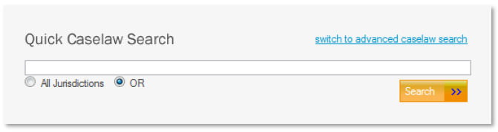
Similarly, you will also notice that as you search, Fastcase will auto-populate the area of the Advanced Caselaw Search page labeled “Recently Searched Jurisdictions” with the last four jurisdictions that you have selected for your searches.
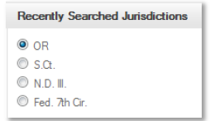
b. Last 10 Searches
If your research project gets interrupted and you want to return to the search you were working on, navigate to the Quick Case Law Search page. In the middle of the page under the heading “Last 10 Searches”, Fastcase records – you guessed it – the last 10 searches that you performed. The searches are listed according to the search terms you used for each search. If you click on the any of the listed searches, you will be taken directly to the corresponding search results.
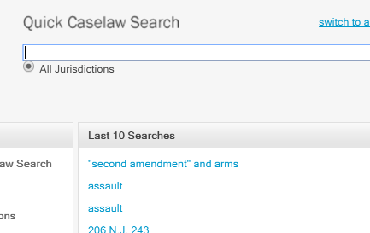
c. Favorite Documents:
Recently Viewed Documents:
Fastcase also tracks the last 10 documents that you have viewed and automatically stores them in your personalized library for easy access. To access a recent document, select ―Go to Recent Documents‖ from the ―My Library‖ menu.
Favorite Documents:
Fastcase allows you to save up to 10 documents in your personal library of favorites. When viewing a document that you want to save, click the “Add to My Favorites” link at the top left side of the screen. To access a saved document, select “Go to Favorite Documents” from the “My Library” menu.
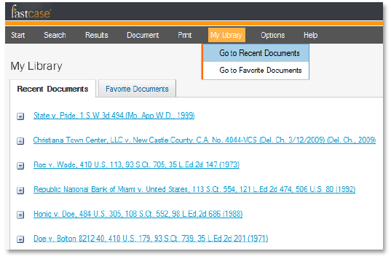

APPENDIX A|A LITTLE BIT ABOUT US

Phil and Ed’s Excellent Adventure.

Fastcase, Inc. was founded in 1999 by CEO, Edward J. Walters and President, Phillip J. Rosenthal. Ed and Phil met while working as associates at the prestigious Washington D.C. law firm, Covington & Burling. The idea for Fastcase came to them after a client made an unusual request.
“[T]he more exciting challenge [i]s to make legal research smarter, faster and easier because, even more critical than saving money is saving time.”
This client, balking at the firm’s legal research bills, challenged them to perform their case law research using free resources on the Internet. Ed and Phil were pleasantly surprised to learn that even in 1999, a wealth of information was already available as many courts had started posting legal decisions on the web.
Ed, a graduate of the University of Chicago Law School who once worked as a speechwriter for President George H.W. Bush, and Phil, a Caltech-trained physicist, immediately saw an opportunity to develop a smarter and more accessible legal research—and perhaps even disrupt the Westlaw/Lexis-Nexis duopoly in the process.
[W]e're building a world where access to the law is like access to power outlets: simple, ubiquitous, and inexpensive.

In December 1999, they decided to take the leap. After bidding farewell to their law firm, they quickly teamed up with Chief Technology Officer, Andrew Schiebler—and Fastcase was born.
The way Fastcase CEO, Ed Walters, sees the world, access to the law should be treated more like a public resource. “Law is one of the last walled gardens remaining on the Internet. At Fastcase, we're building a world where access to the law is like access to power outlets: simple, ubiquitous, and inexpensive. The law applies everywhere; we're going to make it available everywhere, too.
Over 15 years later, Fastcase is breaking down the walls to access and democratizing legal research. Fastcase continues to be the fastest-growing legal research company committed to pushing the technological envelope by developing the industry’s most advanced and powerful legal research tools. It is also one of the world’s most trusted legal research services, serving over 800,000 lawyers from 27 state bar associations, numerous law firms, dozens of membership organizations and a growing number of law schools.
What is the secret to Fastcase’s success? It is actually quite simple: Fastcase provides state-of-the-art legal research capabilities for a fraction of the price of traditional services.
Fastcase’s smart search technology conserves precious (and expensive) legal research time. It’s smarter and more powerful tools sort the most relevant and most authoritative cases to the top of the results list, integrate citation analysis into every case law search, and bring search results to life with a four-dimensional Interactive Timeline.
Indeed, Fastcase is the first legal research provider to move legal research beyond the outdated “search-results-document” paradigm, with powerful data visualization tools that create beautiful, four-dimensional maps of search results. The most important cases jump off the pages in these maps—just one of many exciting tools that make Fastcase a smarter alternative for legal research.
As Fastcase President, Phil Rosenthal, explains, "Initially I was appalled how much it cost attorneys just to get access to the law and knew we could make it affordable. I quickly realized that the more exciting challenge was to make legal research smarter, faster and easier because, even more critical than saving money is saving time."

APPENDIX B|SAMPLE RESEARCH EXCERCISES

Below you will find sample research exercises that you can use to help your students familiarize themselves with Fastcase. We have included suggested research paths for each exercise, but these are only suggestions. There are many additional research paths that may yield the same or similar results.
BASIC
1| Find this case using only the party names: Gideon v. Wainwright
- Search | Gideon w/10 Wainwright
- Result | Gideon v. Wainwright, 372 U.S. 335 (1963).
- Your case you will most likely appear in your top 10 results. You can improve your results by specifying the jurisdiction. Here, Gideon is 9th on the list when searched in All Jurisdictions and 2nd on the list when searched within U.S. Supreme Court.
2| Which section of the U.S. Code that addresses defines election day for the presidential election?
- Search | Tuesday w/15 elect* in the U.S. Code.
- Result | 3 U.S.C. Sec. 1. Time of appointing electors.
3| How many votes are required to amend the Oregon Constitution?
- Search | amend* w/10 constitution in the Oregon Constitution.
- Result | OR. Const. Art XVII Sec. 1 Method of Amending Constitution requires a majority of the legislature to approve an amendment.
4| What is the maximum size of a Grand Jury according to the Federal Rules of Criminal Procedure?
- Navigate to | Fed. R. Crim. P. 6 in Outline View.
- Under part four .The Grand Jury, the Indictment, and the Information,. click on, Rule 6, .The Grand Jury,. to find that a grand jury must have 16 to 23 members.
5| How would you contrast a search for decisions (any jurisdiction) citing 42 U.S.C. § 1983?
- Search | .42 U.S.C. 1983. OR .42 U.S.C. w/3 1983 in All Jurisdictions.

ADVANCED
1| You are an attorney practicing in the District of Connecticut. Conduct a search for federal cases addressing the constitutionality of police searches of automobiles.
- Do your search results include the following decisions?
Carroll v. United States, 267 U.S. 132 (1925).
Arizona v. Gant, 556 U.S. __, 2009, 129 S. Ct. 1710 (2009).
United States v. Ochs, 595 F.2d 1247 (2d Cir. 1979).
Wilkinson v. Forst, 639 F. Supp. 518 (D. Conn. 1986).
- If not, how could you modify your search terms so that your search results include these decisions?
- Search | ("fourth amendment" w/35 search* w/35 vehicle*) or ("fourth amendment" w/35 search* w/35 automobile*) in U.S. Supreme Court, Second Circuit and District of Connecticut.
- What is the most recent Connecticut case citing the Supreme Court’s decision in Arizona v. Gant?
How did the Connecticut Supreme Court distinguish Gant?
- In State v. Butler, 296 Conn. 62 (2010), the Connecticut Supreme Court held that Gant did not control the case at bar because Gant dealt with a search incident to arrest as opposed to a protective search.
2| What is the Supreme Court’s most recent decision addressing the right to bear arms under the Second Amendment?
- Were you able to identify the following decision?
District of Columbia v. Heller, 554 U.S. 290, 128 S. Ct. 2783 (2008).
- If not, how could you modify your search terms so that your search results include Heller?
- Search | .second amendment. and arms in Supreme Court cases
- Sort by | Decision Date
- What is the holding of Heller?
- Heller holds that the Second Amendment protects individual’s right to possess firearms in the District of Columbia.
3| Construct a search for cases (any jurisdiction) discussing secondary liability for copyright infringement. Look at the Interactive Timeline for your search results. What can you glean about the trends in case law on this topic from the timeline?
- Search | copyright w/25 second* w/15 liab* or (copyright and (vicarious or contributory))
- The volume of litigation seems to have increased after the Supreme Court’s Sony decision. There is another spike in 2001. What could be motivating these trends?

