Fastcase Marketing
For Bar Associations

Contents
Social Media Bytes 4
May 6, 2019 5
Tweet: 5
Facebook/LinkedIn/Newsletter: 5
May 13, 2019 5
Tweet: 5
Facebook/LinkedIn/Newsletter: 6
May 20, 2019 6
Tweet: 6
Facebook/LinkedIn/Newsletter: 7
May 27, 2019 8
Tweet: 8
Facebook/LinkedIn/Newsletter: 8
Additional May 2019 9
Tweet: 9
Facebook/LinkedIn/Newsletter: 9
Additional May 2019 9
Tweet: 9
Facebook/LinkedIn/Newsletter: 10
June 3, 2019 11
Tweet: 11
Facebook/LinkedIn/Newsletter: 11
June 10, 2019 11
Tweet: 11
Facebook/LinkedIn/Newsletter: 12
June 17, 2019 12
Tweet: 12
Facebook/LinkedIn/Newsletter: 13
June 24, 2019 13
Tweet: 13
Facebook/LinkedIn/Newsletter: 14
June Additional 2019 15
Tweet: 15
Facebook/LinkedIn/Newsletter: 15

Social Media Bytes

This document contains content you are invited to trickle out to your members in May of 2019. This same content is also available at www.fastcase.com/explore. You are welcome to use this copy in any manner you want without obtaining our permission. We hereby grant you a non-exclusive right to reproduce, edit, publish, and reuse any material contained within this file. We hope you enjoy this content and find it to be a useful tool. Because this letter is sent to all of our bar association partners, we use the term [Your Bar Here] within our social media bytes so you can insert your organization’s name.

All images are optional additions to your posts. To use, left click on the image to access the hosted content or right click and select “Save as Picture” to download. Please send any suggestions, questions, and comments to Zuri Blackmon at zblackmon@fastcase.com. Look for the next issue for July and August 2019 at the end of June.

We offer a comprehensive weekly marketing campaign that you may either choose to reproduce exactly or edit to meet your marketing needs.

A proposed timeline is provided, but feel free to deviate as appropriate. Please do not push this copy all at once – this information is intended to be released gradually over the month. Feel free to use and distribute any of these bytes in newsletters, tips, publications, videos, or whatever format you desire. You do not need our permission.
May 2019

May 6, 2019
Tweet: @fastcase offers free webinars on how to conduct legal research. These webinars are available for CLE credit in many jurisdictions. See the upcoming May dates here: https://bit.ly/2Etxofo.

Facebook/LinkedIn/Newsletter: @fastcase offers free webinars on how to conduct legal research. These webinars are available for CLE credit in many jurisdictions. See the links below to sign up for the May sessions.

Introduction to Legal Research on Fastcase 7
Webinar Date: Thursday, May 2, 2019
Webinar Time: 1:00 PM - 2:00 PM Eastern
https://register.gotowebinar.com/register/3361082097038342403

Data Analytics: Fastcase and Docket Alarm
Webinar Date: Thursday, May 9, 2019
Webinar Time: 1:00 PM - 2:00 PM Eastern
https://register.gotowebinar.com/register/1071798832450936835

Introduction to Boolean on Fastcase 7
Webinar Date: Thursday, May 16, 2019
Webinar Time: 1:00 PM - 2:00 PM Eastern
https://register.gotowebinar.com/register/5590803717253004034

Ethics and Legal Research
Webinar Date: Thursday, May 23, 2019
Webinar Time: 1:00 PM - 2:00 PM Eastern
https://register.gotowebinar.com/register/199892708709256450

May 13, 2019
Tweet: @Fastcase 50 nominations are officially open for 2019! Help us celebrate the inspiring, game changing, crazy smart people shaping the practice of law today. Nominate your heroes here: https://www.fastcase.com/fastcase50/#nominations

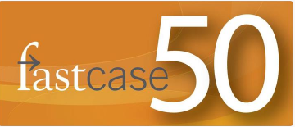

Facebook/LinkedIn/Newsletter: Guess what time it is? @Fastcase 50 nominations are officially open for 2019! Help us celebrate the inspiring, game changing, crazy smart people shaping the practice of law today. Nominate your heroes here: https://www.fastcase.com/fastcase50/#nominations

May 20, 2019
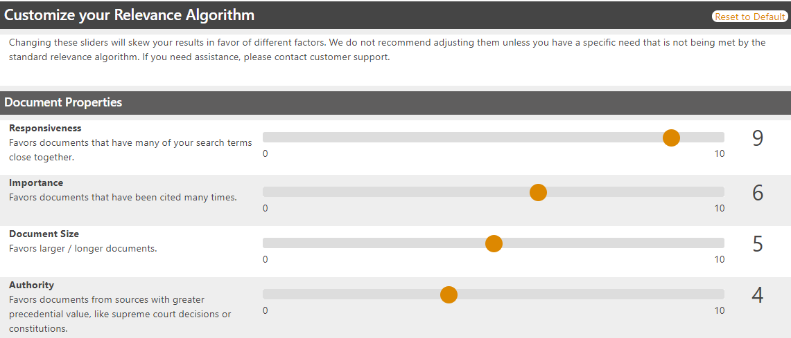
Tweet: The recent Relevance Algorithm overhaul in @fastcase 7 allows you to fine tune the sorting of documents! There are over a quadrillion possible configurations making it easy to choose which one is right for you!
Facebook/LinkedIn/Newsletter: Fine tune the way your documents get sorted for each search. With the recent Relevance Algorithm overhaul in @fastcase 7 you can now favor documents from the size of the length of the document to how often it's printed. There are over a quadrillion possible configurations making it easy to choose which one is right for you!

May 27, 2019
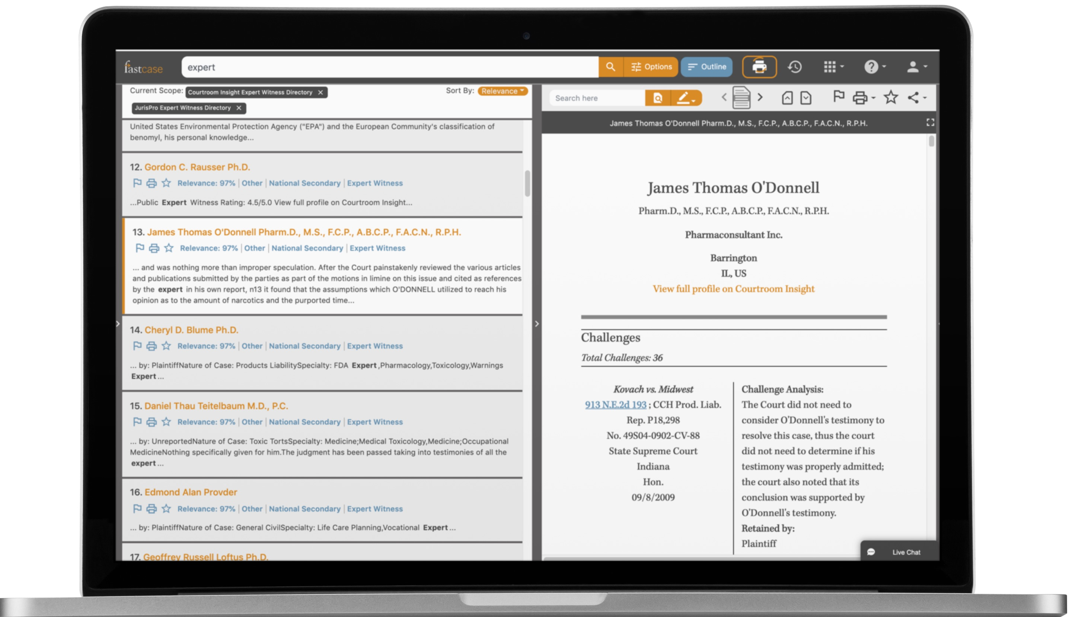
Tweet: You can search over 100K expert witness profiles in @fastcase 7 through Fastcase’s partnership with Courtroom Insight & JurisPro. To search expert witness profiles, run your search, then filter by document type to the left of your results.

Facebook/LinkedIn/Newsletter: Over 100,000 expert witness profiles are searchable in @fastcase 7 through Fastcase’s partnership with Courtroom Insight and JurisPro. To search expert witness profiles, simply enter your search terms, run your search, then filter by document type to the left of your results.

Additional May 2019
Tweet: Jump straight to the outline view from your search results in @fastcase 7 with a single click. See the surrounding documents to a code, statute, or other outlined material.
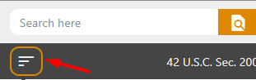

Facebook/LinkedIn/Newsletter: Jump straight to the outline view from your search results in @fastcase 7 with a single click. See the surrounding documents to a code, statute, or other outlined material.

Additional May 2019
Tweet: Check out web accessibility improvements in @fastcase. To view the optional high-contrast mode, select the profile button in the top-right corner, then select “Switch to High Contrast”.
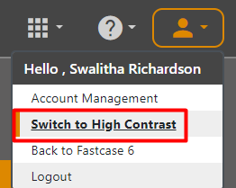
Facebook/LinkedIn/Newsletter: Check out web accessibility improvements in @fastcase. The high contrast feature is available for users with color blindness or low visual acuity. To view the optional high-contrast mode, select the profile button in the top-right corner, then select “Switch to High Contrast”.

June 2019

June 3, 2019
Tweet: @fastcase offers free webinars on how to conduct legal research. These webinars are available for CLE credit in many jurisdictions. See the upcoming June dates here: https://bit.ly/2Etxofo.

Facebook/LinkedIn/Newsletter: @fastcase offers free webinars on how to conduct legal research. These webinars are available for CLE credit in many jurisdictions. See the links below to sign up for the June sessions.

Introduction to Legal Research on Fastcase 7
Webinar Date: Thursday, June 6, 2019
Webinar Time: 1:00 PM - 2:00 PM Eastern
https://register.gotowebinar.com/register/1142884458209561603

Data Analytics: Fastcase and Docket Alarm
Webinar Date: Thursday, June 13, 2019
Webinar Time: 1:00 PM - 2:00 PM Eastern
https://register.gotowebinar.com/register/1981381921156542211

Introduction to Boolean on Fastcase 7
Webinar Date: Thursday, June 20, 2019
Webinar Time: 1:00 PM - 2:00 PM Eastern
https://register.gotowebinar.com/register/2613682471002999554

Ethics and Legal Research
Webinar Date: Thursday, June 27, 2019
Webinar Time: 1:00 PM - 2:00 PM Eastern
https://register.gotowebinar.com/register/9047137210864655362

June 10, 2019
Tweet: Save time with @fastcase Hotkeys. Fastcase is now entirely navigable without the use of a mouse. You can find a list of keyboard shortcuts to help cut down on navigation time under Help > Hotkeys.
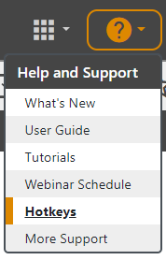

Facebook/LinkedIn/Newsletter: Save time with @fastcase Hotkeys. Fastcase is now entirely navigable without the use of a mouse. You can find a list of keyboard shortcuts to help cut down on navigation time under Help > Hotkeys.

June 17, 2019
Tweet: When running a search in @fastcase 7 only get results included in your subscription with Permission Aware Searching. From the Search Options box, select the Advanced tab and deselect “Include Purchasable Content”.

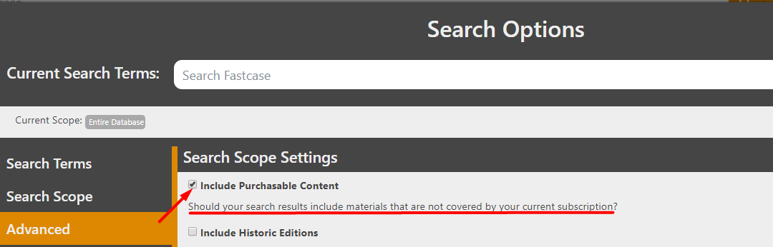

Facebook/LinkedIn/Newsletter: When running a search in @fastcase 7 only get results included in your subscription with Permission Aware Searching. From the Search Options box, select the Advanced tab and deselect “Include Purchasable Content”.

June 24, 2019
Tweet: Don’t remember the search you ran last week or last month? @fastcase 7 now groups all your searches and documents by day so you can see exactly when you did what.
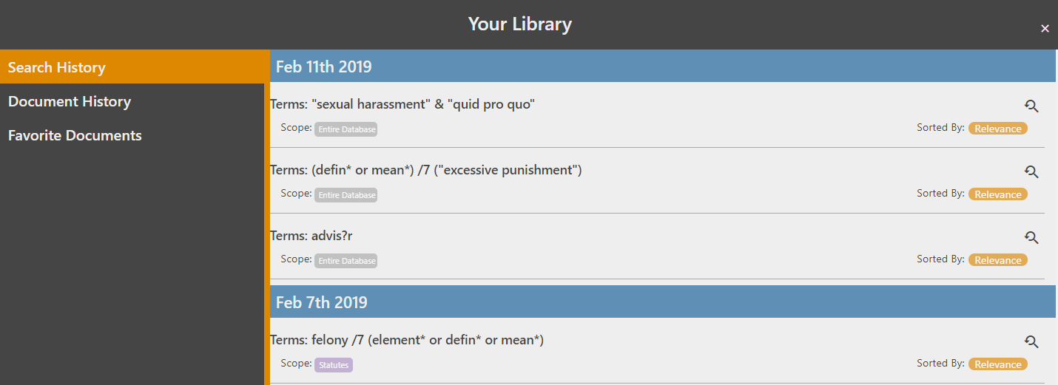
Facebook/LinkedIn/Newsletter: Don’t remember the search you ran last week or last month? @fastcase 7 now groups all your searches and documents by day, so you can see exactly when you did what.

June Additional 2019
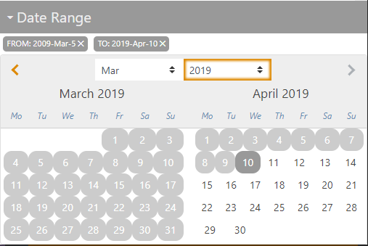
Tweet: Want to filter your search results by date? Setting a date range for your search is now much easier and more intuitive in @fastcase 7. Just click the start date, then click the end date!

Facebook/LinkedIn/Newsletter: Want to filter your search results by date? Setting a date range for your search is now much easier and more intuitive in @fastcase 7. Just click the start date, then click the end date!

