Fastcase Marketing
For Bar Associations

Contents
September 3, 2019 5
Tweet: 5
Facebook/LinkedIn/Newsletter: 5
September 9 5
Tweet: 5
Facebook/LinkedIn/Newsletter: 6
September 16 6
Tweet: 6
Facebook/LinkedIn/Newsletter: 7
September 7
Tweet: 7
Facebook/LinkedIn/Newsletter: 7
September 23 8
Tweet: 8
Facebook/LinkedIn/Newsletter: 9
October 2019 9
September 30 9
Tweet: 9
Facebook/LinkedIn/Newsletter: 9
October 7 10
Tweet: 10
Facebook/LinkedIn/Newsletter: 10
October 14 11
Tweet: 11
Facebook/LinkedIn/Newsletter: 11
October 21 12
Tweet: 12
Facebook/LinkedIn/Newsletter: 12
October 28 13
Tweet: 13
Facebook/LinkedIn/Newsletter: 13

Social Media Bytes

This document contains content you are invited to trickle out to your members in September of 2019. This same content is also available at www.fastcase.com/explore. You are welcome to use this copy in any manner you want without obtaining our permission. We hereby grant you a non-exclusive right to reproduce, edit, publish, and reuse any material contained within this file. We hope you enjoy this content and find it to be a useful tool. Because this letter is sent to all of our bar association partners, we use the term [Your Bar Here] within our social media bytes so you can insert your organization’s name.

All images are optional additions to your posts. To use, left click on the image to access the hosted content or right click and select “Save as Picture” to download. Please send any suggestions, questions, and comments to Zuri Blackmon at zblackmon@fastcase.com. Look for the next issue for November and December 2019 at the end of October.

We offer a comprehensive weekly marketing campaign that you may either choose to reproduce exactly or edit to meet your marketing needs.

A proposed timeline is provided, but feel free to deviate as appropriate. Please do not push this copy all at once – this information is intended to be released gradually over the month. Feel free to use and distribute any of these bytes in newsletters, tips, publications, videos, or whatever format you desire. You do not need our permission.
September 2019

September 3, 2019
Tweet: @fastcase offers free webinars on how to conduct legal research. These webinars are available for CLE credit in many jurisdictions. See the upcoming September dates here: https://bit.ly/2Etxofo.

Facebook/LinkedIn/Newsletter: @fastcase offers free webinars on how to conduct legal research. These webinars are available for CLE credit in many jurisdictions. See the links below to sign up for the September sessions.

Introduction to Legal Research on Fastcase 7
Webinar Date: Thursday, September 5, 2019
Webinar Time: 1:00 PM - 2:00 PM Eastern
https://register.gotowebinar.com/register/6017112962628939523

Data Analytics: Fastcase and Docket Alarm
Webinar Date: Thursday, September 12, 2019
Webinar Time: 1:00 PM - 2:00 PM Eastern
https://register.gotowebinar.com/register/297806418171056643

Introduction to Boolean on Fastcase 7
Webinar Date: Thursday, September 19, 2019
Webinar Time: 1:00 PM - 2:00 PM Eastern
https://register.gotowebinar.com/register/2508266793689986050

Ethics and Legal Research
Webinar Date: Thursday, September 26, 2019
Webinar Time: 1:00 PM - 2:00 PM Eastern
https://register.gotowebinar.com/register/6541641581744522754

September 9
Tweet: Need to filter your search by a specific jurisdiction or date? Add jurisdictional filters in @fastcase. Click on “Select Jurisdiction” at the top of the toolbar in Fastcase 7, then add your jurisdiction, authority level, document type or date filter.

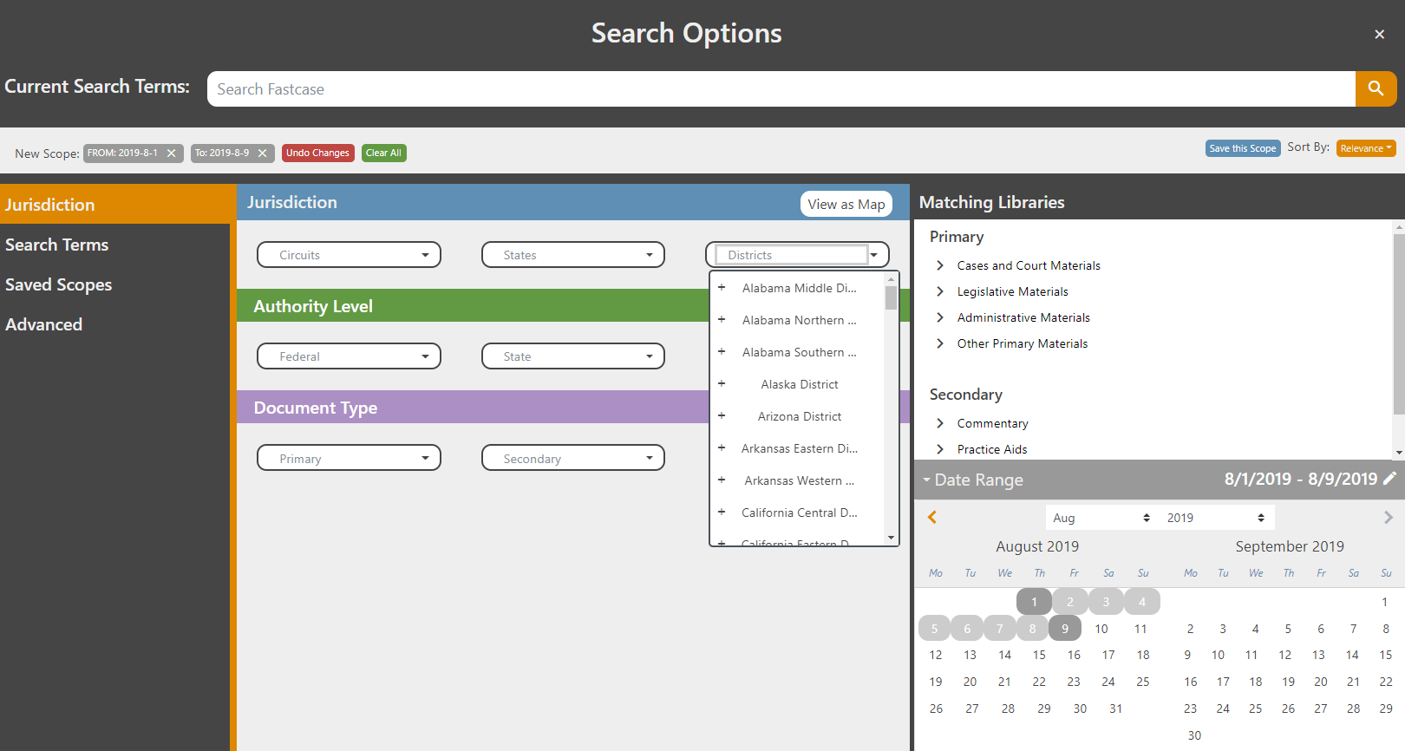

Facebook/LinkedIn/Newsletter: Need to filter your search by a specific jurisdiction or date? Add jurisdictional filters in @fastcase. Click on “Select Jurisdiction” at the top of the toolbar in Fastcase 7, then add your jurisdiction, authority level, document type or date filter.

September 16
Tweet: Just have the pincite for a case? Enter the pincite in Fastcase 7 and @fastcase will find the document for you. To search for page 187 in Gregg v. Georgia, 428 U.S. 153, replace the first page number with the pincite, 428 U.S. 187.

Facebook/LinkedIn/Newsletter: Just have the pincite for a case? Enter the pincite in Fastcase 7 and @fastcase will find the document for you. To search for page 187 in Gregg v. Georgia, 428 U.S. 153, replace the first page number with the pincite, 428 U.S. 187.

September
Tweet: View annotations in @fastcase 7 by clicking on the “Annotations” button at the bottom of the statute or code or by clicking on the A next to the printer icon.

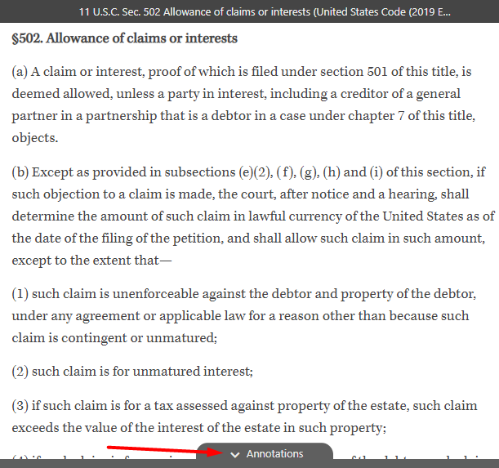
Facebook/LinkedIn/Newsletter: View annotations in @fastcase 7 by clicking on the “Annotations” button at the bottom of the statute or code or by clicking on the “A” next to the printer icon.

September 23
Tweet: New to Fastcase 7? Learn about new features and search options with a webinar featuring @fastcase expert Erin Page every Monday, at 2:00 p.m. ET. Click here to register: https://register.gotowebinar.com/rt/8172724204113848076

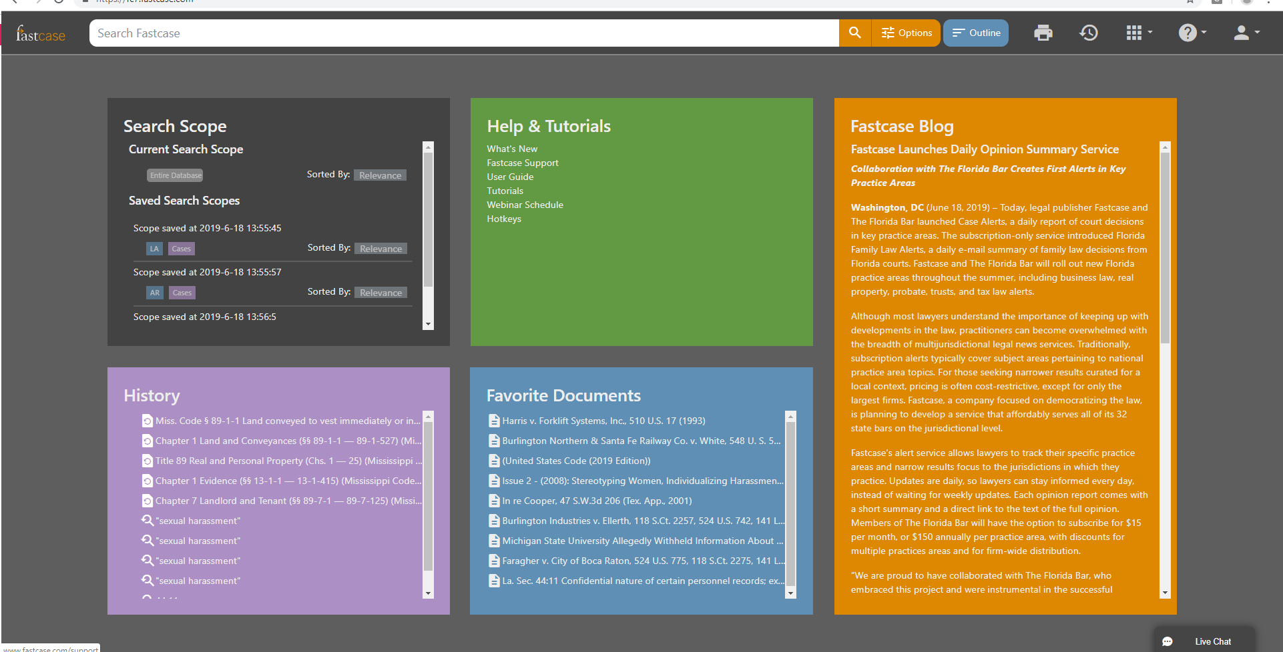
Facebook/LinkedIn/Newsletter: New to Fastcase 7? Learn about new features and search options with a webinar featuring @fastcase expert Erin Page every Monday, at 2:00 p.m. ET. Click here to register: https://register.gotowebinar.com/rt/8172724204113848076

October 2019

September 30
Tweet: @fastcase offers free webinars on how to conduct legal research. These webinars are available for CLE credit in many jurisdictions. See the upcoming October dates here: https://bit.ly/2Etxofo.

Facebook/LinkedIn/Newsletter: @fastcase offers free webinars on how to conduct legal research. These webinars are available for CLE credit in many jurisdictions. See the links below to sign up for the October sessions.

Introduction to Legal Research on Fastcase 7
Webinar Date: Thursday, October 3, 2019
Webinar Time: 1:00 PM - 2:00 PM Eastern
https://register.gotowebinar.com/register/6776395010840820483

Data Analytics: Fastcase and Docket Alarm
Webinar Date: Thursday, October 10, 2019
Webinar Time: 1:00 PM - 2:00 PM Eastern
https://register.gotowebinar.com/register/4508672069762473475

Introduction to Boolean on Fastcase 7
Webinar Date: Thursday, October 17, 2019
Webinar Time: 1:00 PM - 2:00 PM Eastern
https://register.gotowebinar.com/register/5408085775437578754

Ethics and Legal Research
Webinar Date: Thursday, October 24, 2019
Webinar Time: 1:00 PM - 2:00 PM Eastern
https://register.gotowebinar.com/register/3806820812419141890

October 7
Tweet: Forgot the name of an important case you viewed earlier? View your document history in Fastcase 7 with the date filters. Explore the document date filters by clicking “History and Favorites” from the toolbar, then select the calendar icon in the “Document History” tab.

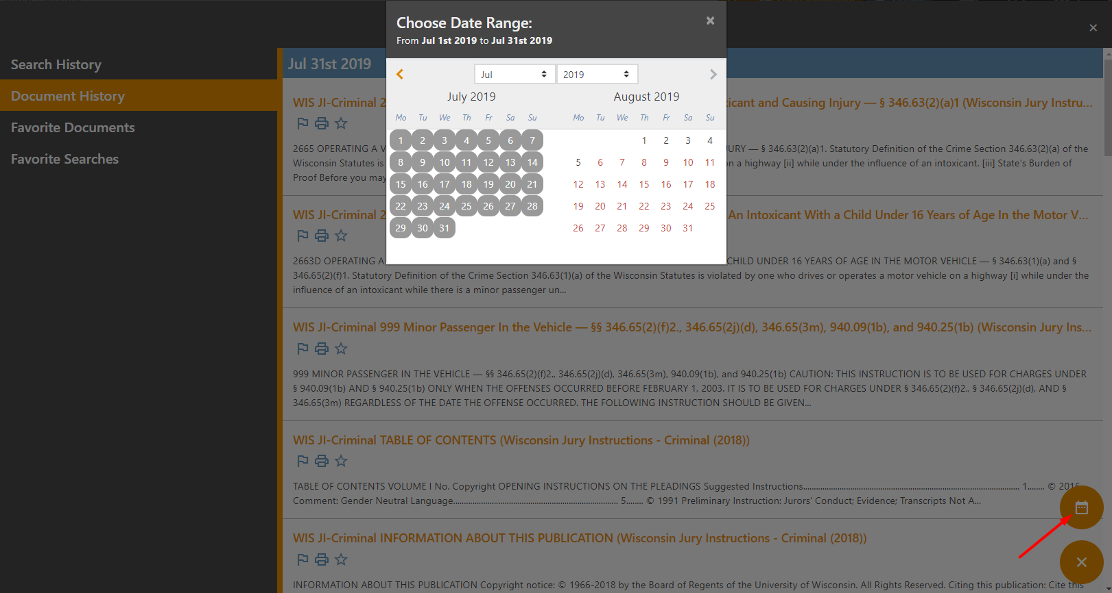

Facebook/LinkedIn/Newsletter: Did you forget the name of an important case you viewed a week earlier? Quickly locate your document history in Fastcase 7 with the addition of date filters. Check out the document date filters by clicking “History and Favorites” from the toolbar, then select the calendar icon in the “Document History” tab.

October 14
Tweet: Not sure what’s included in your bar benefit? With permission aware outlines you can quickly identify all the libraries available to you in @fastcase. Just select the Outline tab, at the top of the toolbar in Fastcase 7, to see the libraries available with your member benefit.

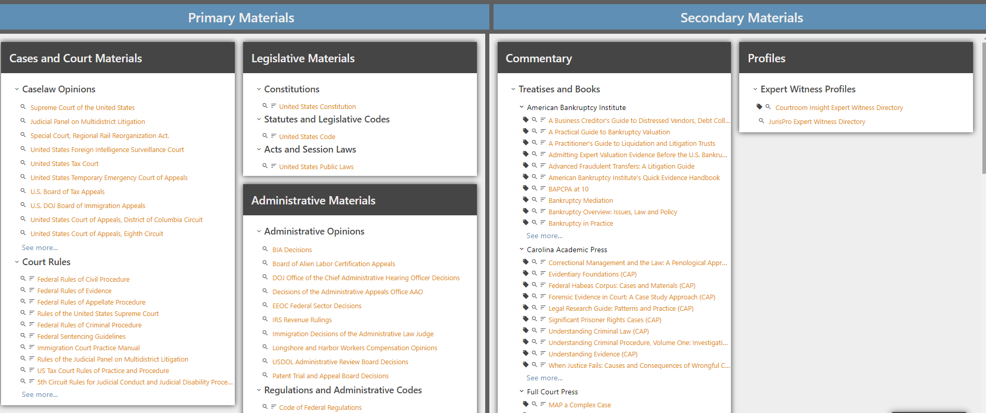

Facebook/LinkedIn/Newsletter: Not sure what’s included in your bar benefit? With permission aware searching you can quickly identify all the libraries available to you in @fastcase. Just select the Outline tab, at the top of the toolbar in Fastcase 7, to see the libraries available with your member benefit.

October 21
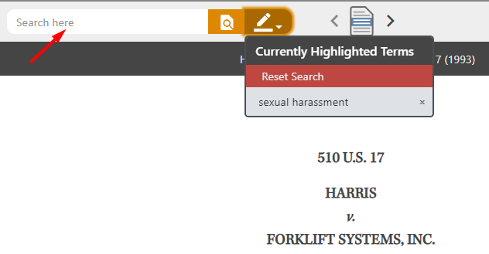
Tweet: Check out @Fastcase 7 today for more features! Find what you need faster with the Find in Document feature. Search additional terms within your document using the search bar in the document view panel. Find terms in your document that were not included in your original search.
Facebook/LinkedIn/Newsletter: Want even more features from @fastcase? Check out Fastcase 7 today! Find what you need even faster with the Find in Document feature. Search additional terms within your document using the search bar in the document view panel. Find terms in your document that were not included in your original search.

October 28
Tweet: Did you know @fastcase offers free research assistance? Reference attorneys are available to assist with research or navigating the database via phone at 1-866-773-2782 Option 2, via email at support@fastcase.com or via Live Chat available at the bottom of the research platform.
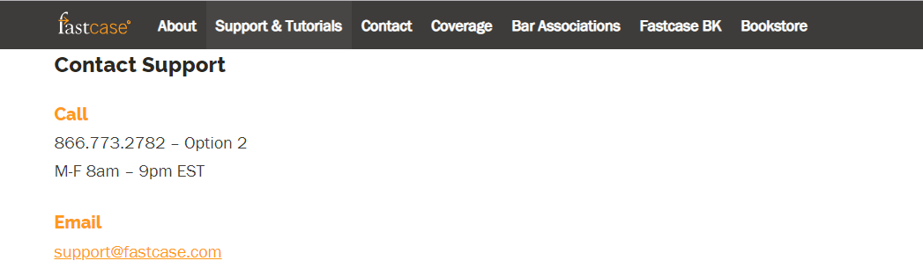
Facebook/LinkedIn/Newsletter: Do you need help with your legal research? As a member benefit @fastcase offers research assistance. Reference attorneys are available to assist with research or navigating the database via phone at 1-866-773-2782 Option 2, via email at support@fastcase.com or via Live Chat using the Live Chat box at the bottom of the research platform.

