Fastcase Marketing
For Bar Associations

Contents
Social Media Bytes 3
November 1, 2019 4
Tweet: 4
Facebook/LinkedIn/Newsletter: 4
November 4, 2019 4
Facebook/LinkedIn/Newsletter: 5
November 11, 2019 5
Tweet: 5
Facebook/LinkedIn/Newsletter: 5
November 18, 2019 6
Tweet: 6
Facebook/LinkedIn/Newsletter: 6
November 25, 2019 7
Tweet: 7
Facebook/LinkedIn/Newsletter: 7
November 27, 2019 7
Tweet: 7
Facebook/LinkedIn/Newsletter: 7
November Alternate 8
Tweet: 8
Facebook/LinkedIn/Newsletter: 8

Social Media Bytes

This document contains content you are invited to send out to your members in November of 2019. This same content is also available at www.fastcase.com/explore. You are welcome to use this copy in any manner you want without obtaining our permission. We hereby grant you a non-exclusive right to reproduce, edit, publish, and reuse any material contained within this file. We hope you enjoy this content and find it to be a useful tool. Because this letter is sent to all of our bar association partners, we use the term [Your Bar Here] within our social media bytes so you can insert your organization’s name.

All images are optional additions to your posts. To use, left click on the image to access the hosted content or right click and select “Save as Picture” to download. Please send any suggestions, questions, and comments to Joe Patz Vineyard at joe@fastcase.com. Look for the next issue for December 2019 at the end of November.

We offer a comprehensive weekly marketing campaign that you may either choose to reproduce exactly or edit to meet your marketing needs.

A proposed timeline is provided, but feel free to deviate as appropriate. Please do not push this copy all at once – this information is intended to be released gradually over the month. Feel free to use and distribute any of these bytes in newsletters, tips, publications, videos, or whatever format you desire. You do not need our permission.
November

November 1, 2019
Tweet: @fastcase offers free webinars on how to conduct legal research. These webinars are available for CLE credit in many jurisdictions. See the upcoming November dates here: https://bit.ly/2Etxofo.

Facebook/LinkedIn/Newsletter: @fastcase offers free webinars on how to conduct legal research. These webinars are available for CLE credit in many jurisdictions. See the links below to sign up for the November sessions.

Introduction to Legal Research on Fastcase 7
Webinar Date: Thursday, November 7, 2019
Webinar Time: 1:00 PM - 2:00 PM Eastern
https://register.gotowebinar.com/register/1626501349151968771

Data Analytics: Fastcase and Docket Alarm
Webinar Date: Thursday, November 14, 2019
Webinar Time: 1:00 PM - 2:00 PM Eastern
https://register.gotowebinar.com/register/5805838504817256963

Introduction to Boolean on Fastcase 7
Webinar Date: Thursday, November 21, 2019
Webinar Time: 1:00 PM - 2:00 PM Eastern
https://register.gotowebinar.com/register/2041452639443275266

November 4, 2019
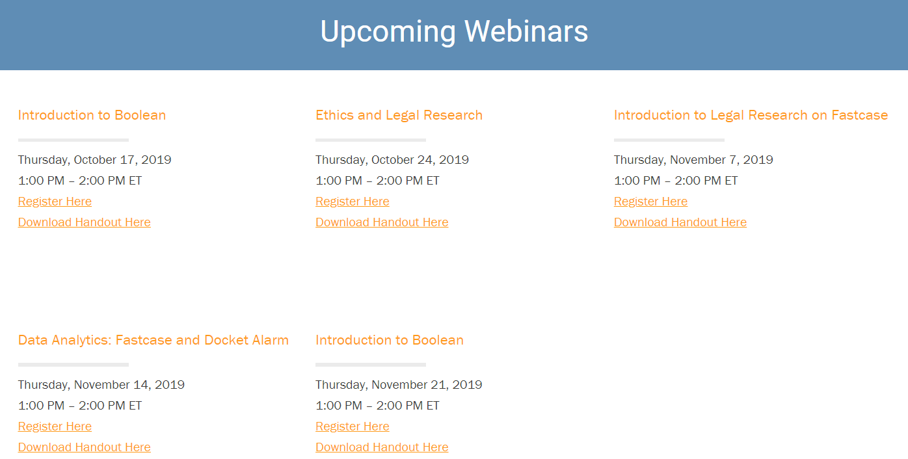
Tweet: Join @fastcase for Thankful Thursdays to get your last minute CLEs before the holidays. CLEs are FREE with your @fastcase bar benefit. Register at http://www.fastcase.com/webinars/. Webinars are offered every Thursday in November, excluding holidays, from 1:00 PM – 2:00 PM ET.

Facebook/LinkedIn/Newsletter: Join @fastcase for Thankful Thursdays to get your last minute CLEs before the holidays. CLEs are FREE with your @fastcase bar benefit. Register at http://www.fastcase.com/webinars/. Webinars are offered every Thursday in November, excluding holidays, from 1:00 PM – 2:00 PM ET.

November 11, 2019
Tweet: Tis the season to get ahead with a tour of Fastcase 7, featuring @fastcase expert Erin Page every Monday, at 2:00 p.m. ET. Click here to register: https://register.gotowebinar.com/rt/8172724204113848076

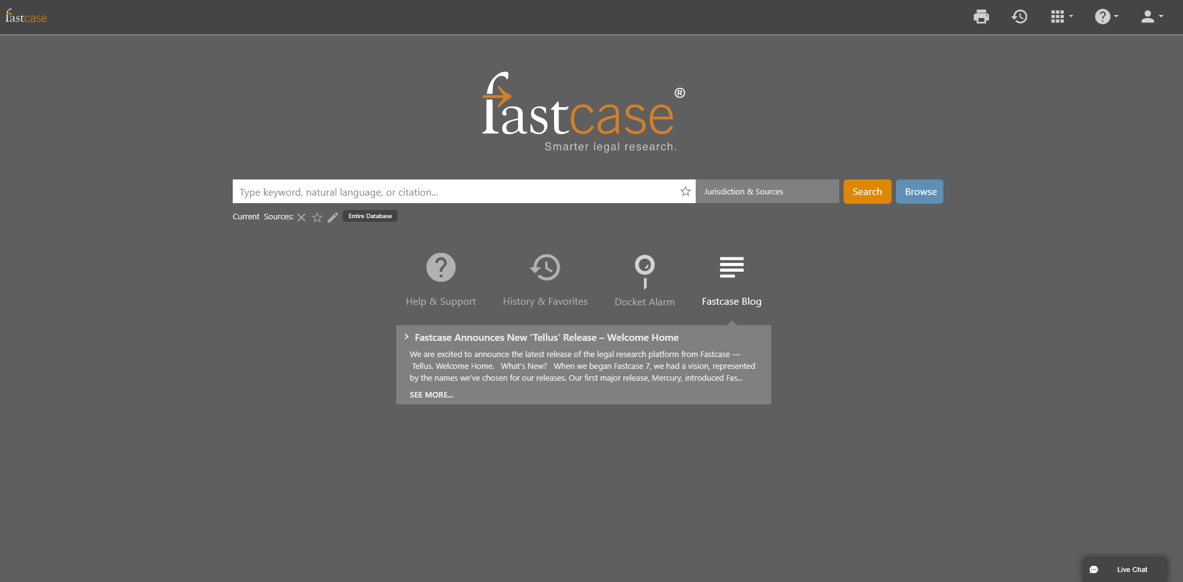

Facebook/LinkedIn/Newsletter: Tis the season to get ahead with a tour of Fastcase 7, featuring @fastcase expert Erin Page every Monday, at 2:00 p.m. ET. Click here to register: https://register.gotowebinar.com/rt/8172724204113848076

November 18, 2019
Tweet: Step into the holidays with comfort using @fastcase time-saving search tips. Try: check /3 fraud instead of “check fraud” to make sure you do not exclude cases with the phrase fraud by check or fraud by worthless check. See other tips here: https://www.fastcase.com/blog/tip-constructing-a-broad-keyword-search/.

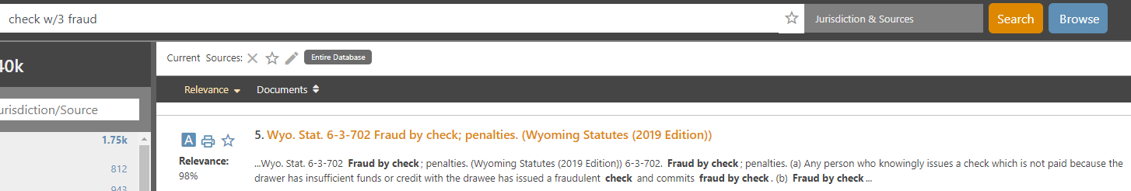

Facebook/LinkedIn/Newsletter: Step into the holidays with comfort using @fastcase time-saving search tips. Try: check /3 fraud instead of “check fraud” to make sure you do not exclude cases with the phrase fraud by check or fraud by worthless check. See other tips here: https://www.fastcase.com/blog/tip-constructing-a-broad-keyword-search/.

November 25, 2019
Tweet: Give a little more this season with @fastcase public links. Share cases or any primary law document on your blogs, social media or with your clients or colleagues. To share a link to a document in Fastcase click the share icon and copy public link to document.

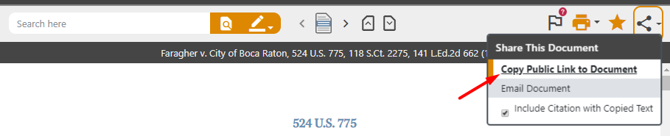

Facebook/LinkedIn/Newsletter: Give a little more this season with @fastcase public links. Share cases or any primary law document on your blogs, social media or with your clients or colleagues. To share a link to a document in Fastcase click the share icon and copy public link to document.

November 27, 2019
Tweet: A note from our friends at @fastcase: the Fastcase offices will be closed Thursday, November 28th and Friday, November 29th. Any messages left with the support team will be returned promptly on Monday. Wishing you a safe and Happy Thanksgiving!

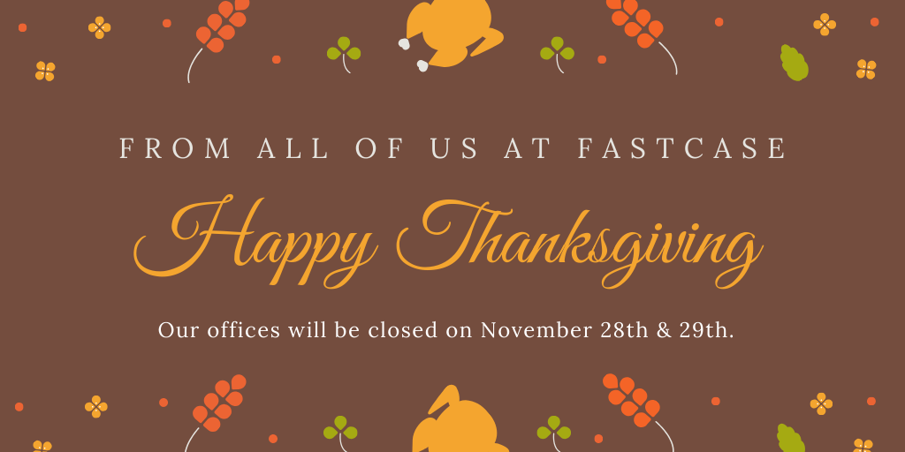

Facebook/LinkedIn/Newsletter: A note from our friends at @fastcase: the Fastcase offices will be closed Thursday, November 28th and Friday, November 29th. Any messages left with the support team will be returned promptly on Monday. Wishing you a safe and Happy Thanksgiving!

November Alternate
Tweet: Dive into research with assistance from @fastcase reference attorneys, free with your bar benefit. Reference attorneys help draft search queries and with questions related to navigating Fastcase.

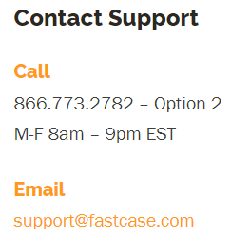

Facebook/LinkedIn/Newsletter: Dive into research with assistance from @fastcase reference attorneys, free with your bar benefit. Reference attorneys help draft search queries and with questions related to navigating Fastcase.

