Fastcase Marketing
For Bar Associations

Contents
Social Media Bytes 3
December 2, 2019 4
Tweet: 4
Facebook/LinkedIn/Newsletter: 4
December 9, 2019 4
Facebook/LinkedIn/Newsletter: 5
December 16, 2019 6
Tweet: 6
Facebook/LinkedIn/Newsletter: 6
December 23, 2019 6
Tweet: 6
Facebook/LinkedIn/Newsletter: 7
December 24, 2019 7
Tweet: 7
Facebook/LinkedIn/Newsletter: 7
December 30, 2019 8
Tweet: 8
Facebook/LinkedIn/Newsletter: 8
December 31, 2019 9
Tweet: 9
Facebook/LinkedIn/Newsletter: 9

Social Media Bytes

This document contains content you are invited to send out to your members in December of 2019. This same content is also available at www.fastcase.com/explore. You are welcome to use this copy in any manner you want without obtaining our permission. We hereby grant you a non-exclusive right to reproduce, edit, publish, and reuse any material contained within this file. We hope you enjoy this content and find it to be a useful tool. Because this letter is sent to all of our bar association partners, we use the term [Your Bar Here] within our social media bytes so you can insert your organization’s name.

All images are optional additions to your posts. To use, left click on the image to access the hosted content or right click and select “Save as Picture” to download. Please send any suggestions, questions, and comments to Joe Patz Vineyard at joe@fastcase.com. Look for the next issue for January 2020 at the end of December.

We offer a comprehensive weekly marketing campaign that you may either choose to reproduce exactly or edit to meet your marketing needs.

A proposed timeline is provided, but feel free to deviate as appropriate. Please do not push this copy all at once – this information is intended to be released gradually over the month. Feel free to use and distribute any of these bytes in newsletters, tips, publications, videos, or whatever format you desire. You do not need our permission.
December

December 2, 2019
Tweet: Save time with @fastcase 7 caselaw search alerts. Don’t miss a case. Set search results as an alert by clicking the bell icon in the search box and receive a daily email of all new cases that match that search query.

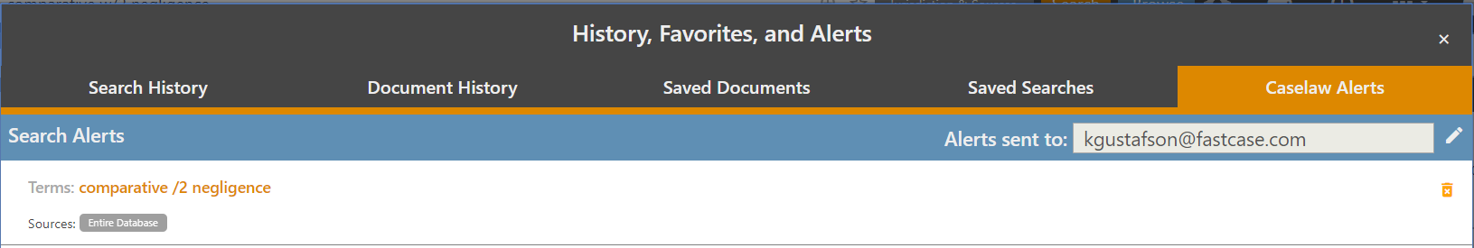

Facebook/LinkedIn/Newsletter: Save time with @fastcase 7 caselaw search alerts. Don’t miss a case. Set search results as an alert by clicking the bell icon in the search box and receive a daily email of all new cases that match that search query.

December 9, 2019
Tweet: Cross off your wish list with @fastcase 7 Personalized Search Libraries. You can now set and select your personalized favorite libraries by clicking the gear icon to the right of the bright blue browse tab. Then pick your customized default, last used, or search all libraries at once under advanced settings.

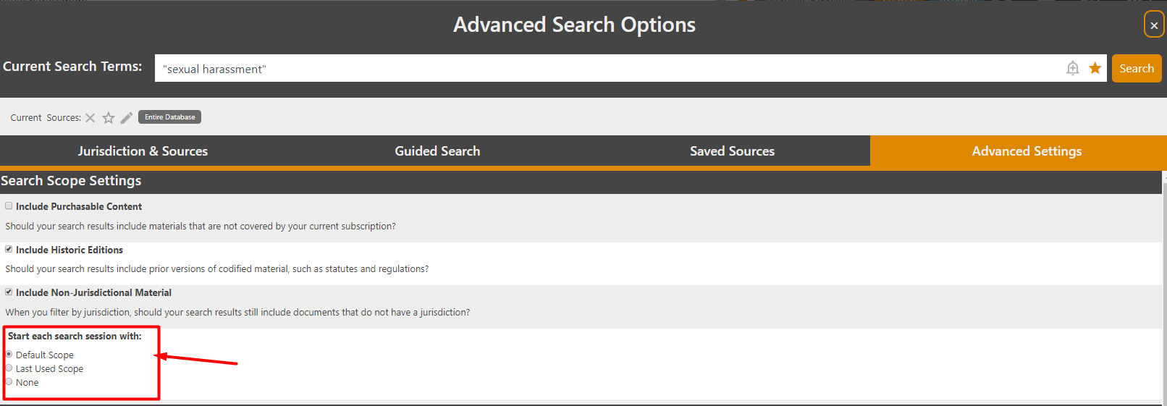
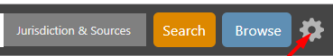

Facebook/LinkedIn/Newsletter: Cross off your wish list with @fastcase 7 Personalized Search Libraries. You can now set and select your personalized favorite libraries by clicking the gear icon to the right of the bright blue browse tab. Then pick your customized default, last used, or search all libraries at once under advanced settings.

December 16, 2019
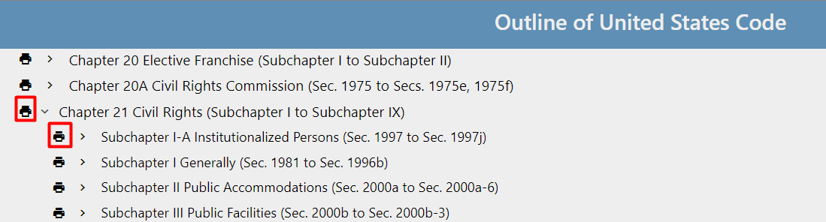
Tweet: On the go? Quickly print multiple documents or statutes with batch printing in @Fastcase 7. To print an entire chapter or subchapter of a code, in outline view, select the printer icon to the left of any title. All of the sections are immediately downloaded to your computer in a single document.

Facebook/LinkedIn/Newsletter: On the go? Quickly print multiple documents or statutes with batch printing in @Fastcase 7. To print an entire chapter or subchapter of a code, in outline view, select the printer icon to the left of any title. All of the sections are immediately downloaded to your computer in a single document.

December 23, 2019
Tweet: Wrap up your research before the holidays with assistance from @fastcase Reference Attorneys, free with your bar benefit. Reference attorneys help draft search queries and answer questions related to navigating Fastcase.

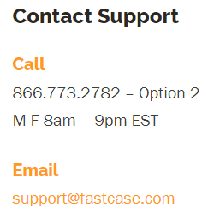

Facebook/LinkedIn/Newsletter: Wrap up your research before the holidays with assistance from @fastcase Reference Attorneys, free with your bar benefit. Reference attorneys help draft search queries and answer questions related to navigating Fastcase.

December 24, 2019
Tweet: A note from our friends at @fastcase: the Fastcase offices will be closed Tuesday, December 4th and Wednesday, December 25th. Any messages left with the support team will be returned promptly on Thursday. Wishing you a safe and Happy Holidays!

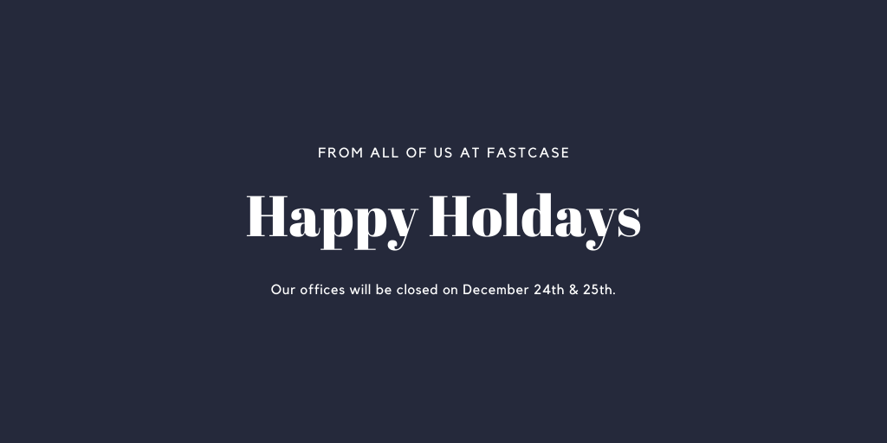

Facebook/LinkedIn/Newsletter: A note from our friends at @fastcase: the Fastcase offices will be closed Tuesday, December 4th and Wednesday, December 25th. Any messages left with the support team will be returned promptly on Thursday. Wishing you a safe and Happy Holidays!

December 30, 2019
Tweet: Spring into the New Year with @fastcase time saving tips. Finish briefs faster using citation with copied text. Highlight the portion of the text you want, right click to copy then paste the text you want anywhere in a document.

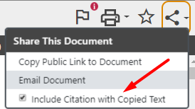
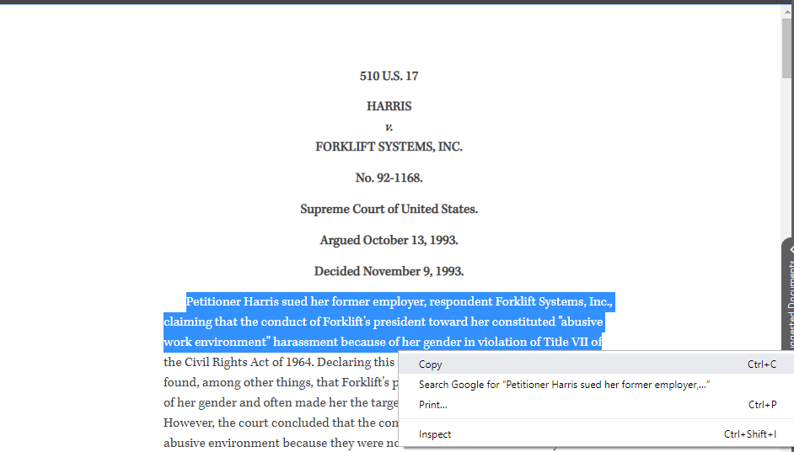

Facebook/LinkedIn/Newsletter: Spring into the New Year with @fastcase time saving tips. Finish briefs faster using citation with copied text. Highlight the portion of the text you want, right click to copy then paste the text you want anywhere in a document.

December 31, 2019
Tweet: A note from our friends at @fastcase: the Fastcase offices will be closed Wednesday, January 1st. Any messages left with the support team will be returned promptly on Thursday. Wishing you a safe and Happy New Year!

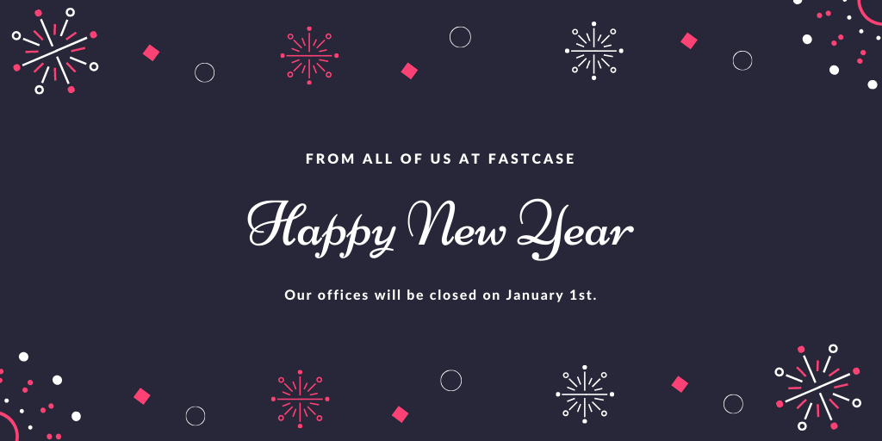

Facebook/LinkedIn/Newsletter: A note from our friends at @fastcase: the Fastcase offices will be closed Wednesday, January 1st. Any messages left with the support team will be returned promptly on Thursday. Wishing you a safe and Happy New Year!

