Fastcase Marketing
For Bar Associations

Contents
Social Media Bytes 3
February 3, 2019 4
Tweet: 4
Facebook/LinkedIn/Newsletter: 4
February 10, 2020 4
Tweet: 4
Facebook/LinkedIn/Newsletter: 5
February 17, 2020 5
Tweet: 5
Facebook/LinkedIn/Newsletter: 6
February 24, 2020 6
Tweet: 6
Facebook/LinkedIn/Newsletter: 6

Social Media Bytes

This document contains content you are invited to send out to your members in February of 2020. This same content is also available at www.fastcase.com/explore. You are welcome to use this copy in any manner you want without obtaining our permission. We hereby grant you a non-exclusive right to reproduce, edit, publish, and reuse any material contained within this file. We hope you enjoy this content and find it to be a useful tool. Because this letter is sent to all of our bar association partners, we use the term [Your Bar Here] within our social media bytes so you can insert your organization’s name.

All images are optional additions to your posts. To use, left click on the image to access the hosted content or right click and select “Save as Picture” to download. Please send any suggestions, questions, and comments to Joe Patz Vineyard at joe@fastcase.com. Look for the next issue for March 2020 at the end of February.

We offer a comprehensive weekly marketing campaign that you may either choose to reproduce exactly or edit to meet your marketing needs.

A proposed timeline is provided, but feel free to deviate as appropriate. Please do not push this copy all at once – this information is intended to be released gradually over the month. Feel free to use and distribute any of these bytes in newsletters, tips, publications, videos, or whatever format you desire. You do not need our permission.
February

February 3, 2019
Tweet: Fall in love with research with @fastcase free webinars on how to conduct legal research. These webinars are available for CLE credit in many jurisdictions. See the upcoming February dates here: https://bit.ly/2Etxofo.

Facebook/LinkedIn/Newsletter: Fall in love with research with @fastcase free webinars on how to conduct legal research. These webinars are available for CLE credit in many jurisdictions. See the links below to sign up for the February sessions.

Introduction to Legal Research on Fastcase 7
Webinar Date: Thursday, February 6, 2020
Webinar Time: 1:00 PM - 2:00 PM Eastern
https://register.gotowebinar.com/register/1619581030618212875

Data Analytics: Fastcase and Docket Alarm
Webinar Date: Thursday, February 13, 2020
Webinar Time: 1:00 PM - 2:00 PM Eastern
https://register.gotowebinar.com/register/2015216100617690635

Introduction to Boolean on Fastcase 7
Webinar Date: Thursday, February 20, 2020
Webinar Time: 1:00 PM - 2:00 PM Eastern
https://register.gotowebinar.com/register/7368354486701008395

Ethics and Legal Research Featuring Fastcase
Webinar Date: Thursday, February 27, 2020
Webinar Time: 1:00 PM - 2:00 PM Eastern
https://register.gotowebinar.com/register/4175582726360497675

February 10, 2020
Tweet: Learn about new features in @fastcase that save you time to spend with a Valentine. Take a tour of Fastcase 7 every Monday, at 2:00 p.m. ET. Click here to register: https://attendee.gotowebinar.com/rt/429934738857076747

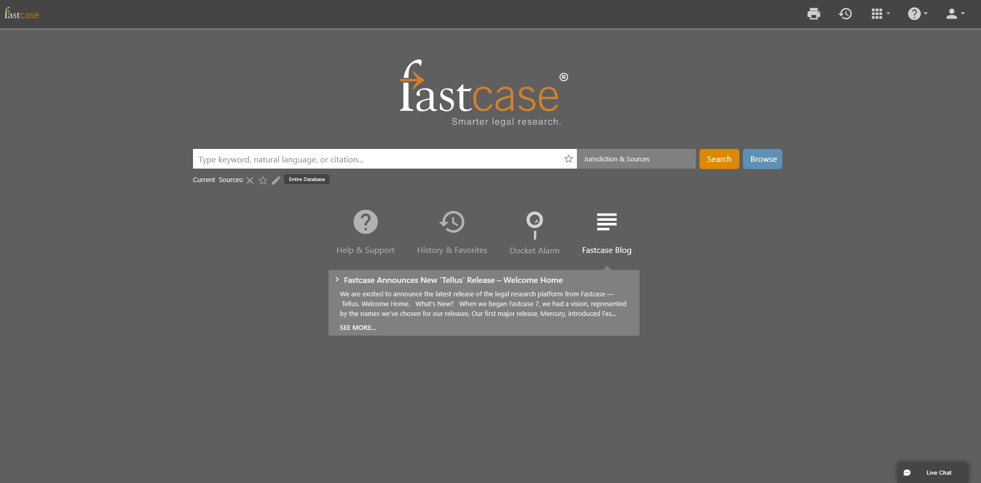

Facebook/LinkedIn/Newsletter: Learn about new features in @fastcase that save you time to spend with a Valentine. Take a tour of Fastcase 7 every Monday, at 2:00 p.m. ET. Click here to register: https://attendee.gotowebinar.com/rt/429934738857076747

February 17, 2020
Tweet: Find what you need fast using @fastcase cited in results. Sorting by cited in results allows you to bring potentially landmark cases, on your topic, to the top of your results. Find your landmark case today with Fastcase 7.

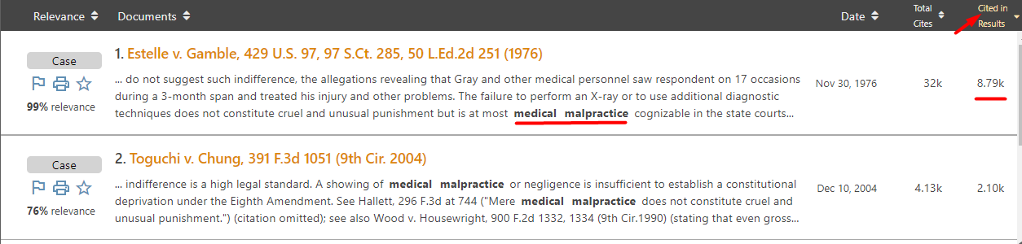

Facebook/LinkedIn/Newsletter: Find what you need fast using @fastcase cited in results. Sorting by cited in results allows you to bring potentially landmark cases, on your topic, to the top of your results. Find your landmark case today with Fastcase 7.

February 24, 2020
Tweet: Want more precision with your searches? Try the proximity operator using @fastcase 7 today! Grant* w/5 “motion for summary judgment” returns cases where the court granted a motion for summary judgment.

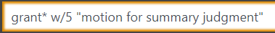

Facebook/LinkedIn/Newsletter: Want more precision with your searches? Try the proximity operator using @fastcase 7 today! Grant* w/5 “motion for summary judgment” returns cases where the court granted a motion for summary judgment.

