Fastcase Marketing
For Bar Associations

Contents
Social Media Bytes 3
December 31, 2019 4
Tweet: 4
Facebook/LinkedIn/Newsletter: 4
January 6, 2020 4
Tweet: 4
Facebook/LinkedIn/Newsletter: 5
January 13, 2020 5
Tweet: 5
Facebook/LinkedIn/Newsletter: 6
January 20, 2020 6
Tweet: 6
Facebook/LinkedIn/Newsletter: 7
January 27, 2020 7
Tweet: 7
Facebook/LinkedIn/Newsletter: 8

Social Media Bytes

This document contains content you are invited to send out to your members in January of 2020. This same content is also available at www.fastcase.com/explore. You are welcome to use this copy in any manner you want without obtaining our permission. We hereby grant you a non-exclusive right to reproduce, edit, publish, and reuse any material contained within this file. We hope you enjoy this content and find it to be a useful tool. Because this letter is sent to all of our bar association partners, we use the term [Your Bar Here] within our social media bytes so you can insert your organization’s name.

All images are optional additions to your posts. To use, left click on the image to access the hosted content or right click and select “Save as Picture” to download. Please send any suggestions, questions, and comments to Joe Patz Vineyard at joe@fastcase.com. Look for the next issue for February 2020 at the end of January.

We offer a comprehensive weekly marketing campaign that you may either choose to reproduce exactly or edit to meet your marketing needs.

A proposed timeline is provided, but feel free to deviate as appropriate. Please do not push this copy all at once – this information is intended to be released gradually over the month. Feel free to use and distribute any of these bytes in newsletters, tips, publications, videos, or whatever format you desire. You do not need our permission.
January

December 31, 2019
Tweet: Start the New Year with @fastcase free webinars on how to conduct legal research. These webinars are available for CLE credit in many jurisdictions. See the upcoming January dates here: https://bit.ly/2Etxofo.

Facebook/LinkedIn/Newsletter: Start the New Year with @fastcase free webinars on how to conduct legal research. These webinars are available for CLE credit in many jurisdictions. See the links below to sign up for the January sessions.

Introduction to Legal Research on Fastcase 7
Webinar Date: Thursday, January 2, 2020
Webinar Time: 1:00 PM - 2:00 PM Eastern
https://register.gotowebinar.com/register/26492036063792651

Data Analytics: Fastcase and Docket Alarm
Webinar Date: Thursday, January 9, 2020
Webinar Time: 1:00 PM - 2:00 PM Eastern
https://register.gotowebinar.com/register/3033631049263801867

Introduction to Boolean on Fastcase 7
Webinar Date: Thursday, January 16, 2020
Webinar Time: 1:00 PM - 2:00 PM Eastern
https://register.gotowebinar.com/register/792014912275094027

Ethics and Legal Research Featuring Fastcase
Webinar Date: Thursday, January 23, 2020
Webinar Time: 1:00 PM - 2:00 PM Eastern
https://register.gotowebinar.com/register/6751725276100122891

January 6, 2020
Tweet: Ease into the New Year with a tour of Fastcase 7, featuring @fastcase expert Erin Page every Monday, at 2:00 p.m. ET. Click here to register: https://attendee.gotowebinar.com/rt/429934738857076747

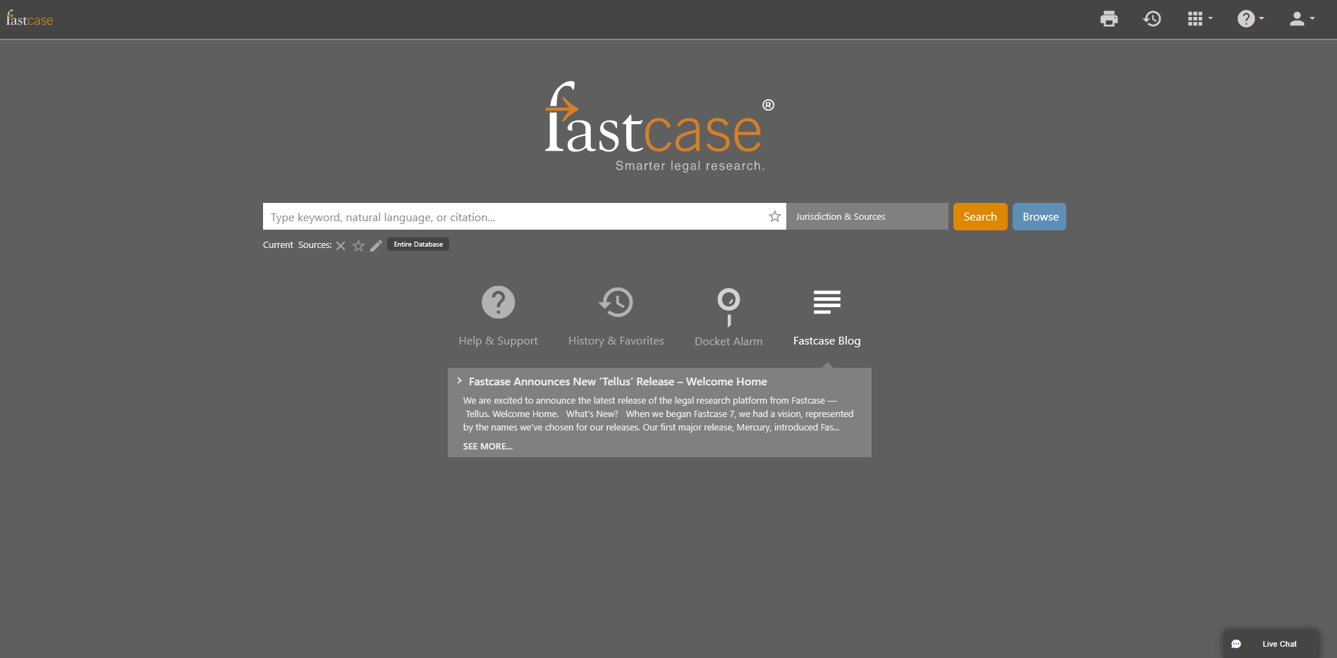

Facebook/LinkedIn/Newsletter: Ease into the New Year with a tour of Fastcase 7, featuring @fastcase expert Erin Page every Monday, at 2:00 p.m. ET. Click here to register: https://attendee.gotowebinar.com/rt/429934738857076747

January 13, 2020
Tweet: Improve your search with one click. Let @fastcase 7 suggest terms to include or exclude from your search using Suggested Terms, an updated Tag Cloud feature. Suggested Terms appear as a list in the bottom left of your search results page. Click the plus to include a term or minus to exclude a term from your search results.

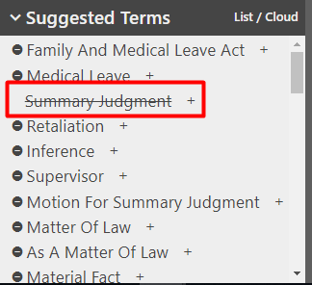

Facebook/LinkedIn/Newsletter: Improve your search with one click in @fastcase. Add or exclude terms using Suggested Terms, an updated Tag Cloud feature in Fastcase 7. Suggested Terms appear as a list in the bottom left of your search results page. Click the plus to include a term or minus to exclude a term from your search results.

January 20, 2020
Tweet: Simplify your research with @fastcase filters. Using Refine Search on the left-hand panel of the search results page in Fastcase 7, refine your search by cases, statutes, court rules, date range and much more. Check out the Refine Search feature today!

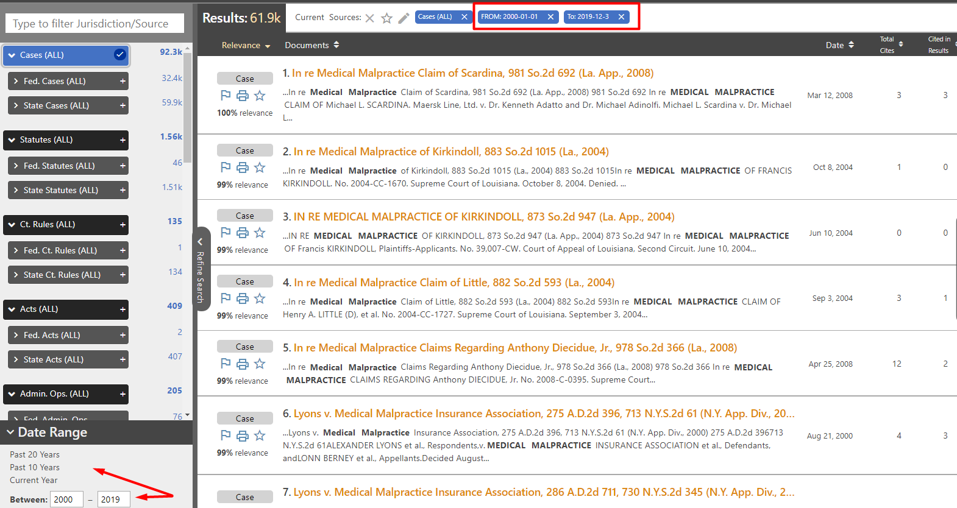

Facebook/LinkedIn/Newsletter: Simplify your research with @fastcase filters. Using Refine Search on the left-hand panel of the search results page in Fastcase 7, refine your search by cases, statutes, court rules, date range and much more. Check out the Refine Search feature today!

January 27, 2020
Tweet: Hit a research block? Save time this year with assistance from @fastcase Reference Attorneys, free with your bar benefit. Reference attorneys help draft search queries and answer questions related to navigating Fastcase.

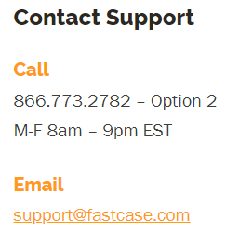

Facebook/LinkedIn/Newsletter: Hit a research block? Save time this year with assistance from @fastcase Reference Attorneys, free with your bar benefit. Reference attorneys help draft search queries and answer questions related to navigating Fastcase.

