Fastcase Partner Marketing
March 2020

Contents
Social Media Bytes 3
March 2, 2020 4
Tweet: 4
Facebook/LinkedIn/Newsletter: 4
March 9, 2020 4
Tweet: 4
Facebook/LinkedIn/Newsletter: 5
March 16, 2020 5
Tweet: 5
Facebook/LinkedIn/Newsletter: 6
March 23 2020 6
Tweet: 6
Facebook/LinkedIn/Newsletter: 7
March 30, 2020 7
Tweet: 7
Facebook/LinkedIn/Newsletter: 8

Social Media Bytes

This document contains content you are invited to send out to your members in March of 2020. This same content is also available at www.fastcase.com/explore. You are welcome to use this copy in any manner you want without obtaining our permission. We hereby grant you a non-exclusive right to reproduce, edit, publish, and reuse any material contained within this file. We hope you enjoy this content and find it to be a useful tool. Because this letter is sent to all of our bar association partners, we use the term [Your Bar Here] within our social media bytes so you can insert your organization’s name.

All images are optional additions to your posts. To use, left click on the image to access the hosted content or right click and select “Save as Picture” to download. Please send any suggestions, questions, and comments to Joe Patz Vineyard at joe@fastcase.com. Look for the next issue for April 2020 at the end of March.

We offer a comprehensive weekly marketing campaign that you may either choose to reproduce exactly or edit to meet your marketing needs.

A proposed timeline is provided, but feel free to deviate as appropriate. Please do not push this copy all at once – this information is intended to be released gradually over the month. Feel free to use and distribute any of these bytes in newsletters, tips, publications, videos, or whatever format you desire. You do not need our permission.

March

March 2, 2020
Tweet: March into spring with @fastcase free webinars on how to conduct legal research. These webinars are available for CLE credit in many jurisdictions. See the upcoming March dates here: https://bit.ly/2Etxofo.

Facebook/LinkedIn/Newsletter: March into spring with @fastcase free webinars on how to conduct legal research. These webinars are available for CLE credit in many jurisdictions. See the links below to sign up for the March sessions.

Introduction to Legal Research on Fastcase 7
Webinar Date: Thursday, March 5, 2020
Webinar Time: 1:00 PM - 2:00 PM Eastern
https://attendee.gotowebinar.com/register/4886280654275599627

Data Analytics: Fastcase and Docket Alarm
Webinar Date: Thursday, March 12, 2020
Webinar Time: 1:00 PM - 2:00 PM Eastern
https://attendee.gotowebinar.com/register/1235465543943149323

Introduction to Boolean on Fastcase 7
Webinar Date: Thursday, March 19, 2020
Webinar Time: 1:00 PM - 2:00 PM Eastern
https://attendee.gotowebinar.com/register/8467156929477109515

Ethics and Legal Research Featuring Fastcase
Webinar Date: Thursday, March 26, 2020
Webinar Time: 1:00 PM - 2:00 PM Eastern
https://attendee.gotowebinar.com/register/8830067234899077643

March 9, 2020
Tweet: Take a tour of Fastcase 7, featuring @fastcase expert Erin Page every Monday, at 2:00 p.m. ET. Click here to register: https://attendee.gotowebinar.com/rt/429934738857076747

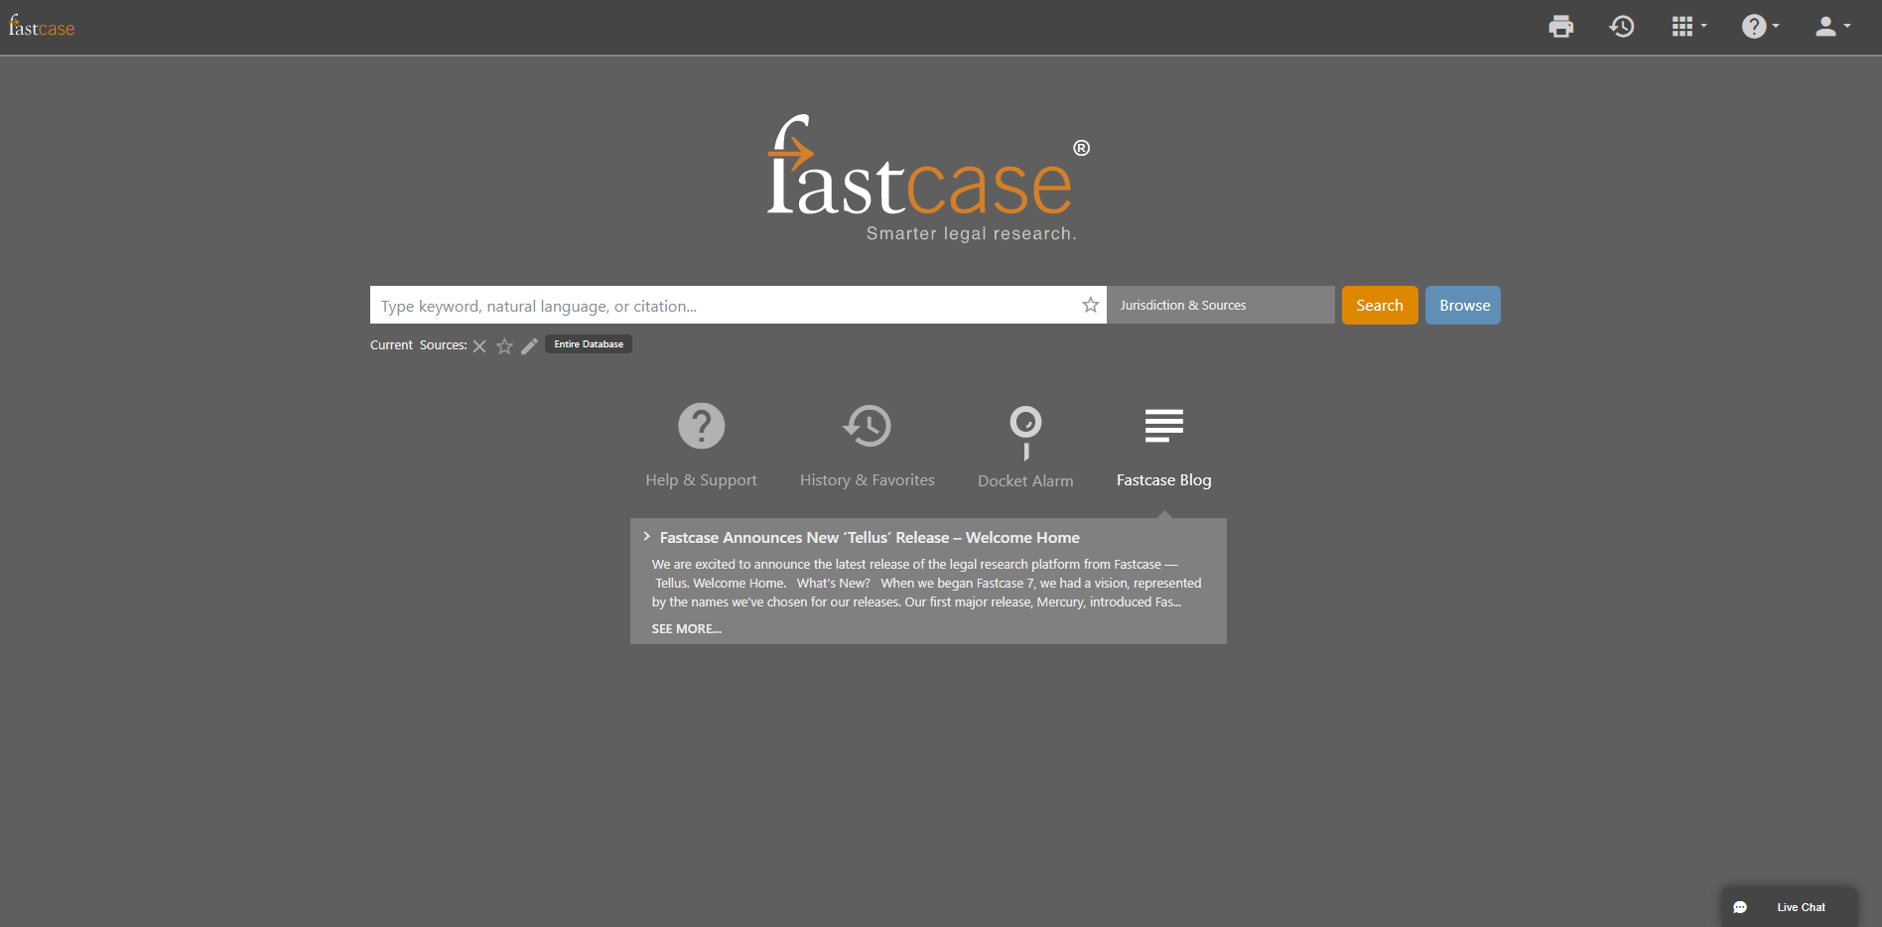

Facebook/LinkedIn/Newsletter: Take a tour of Fastcase 7, featuring @fastcase expert Erin Page every Monday, at 2:00 p.m. ET. Click here to register: https://attendee.gotowebinar.com/rt/429934738857076747

March 16, 2020

Tweet: Give a little more this season with @fastcase public links. Share cases or any primary law document on your blogs, social media or with your clients or colleagues. To share a link to a document in Fastcase click the share icon and copy public link to document.

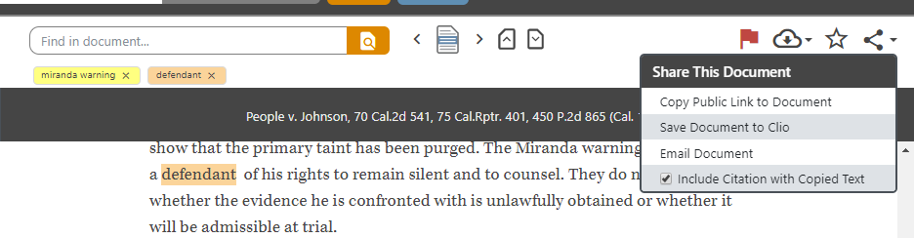

Facebook/LinkedIn/Newsletter: Give a little more this season with @fastcase public links. Share cases or any primary law document on your blogs, social media or with your clients or colleagues. To share a link to a document in Fastcase click the share icon and copy public link to document.

March 23, 2020
Tweet: Wanna see what the pros are talking about? Access Lexblog articles through Fastcase 7 for free. Simply click on “Blogs”, search for your favorite topic, and see what all the buzz is about.

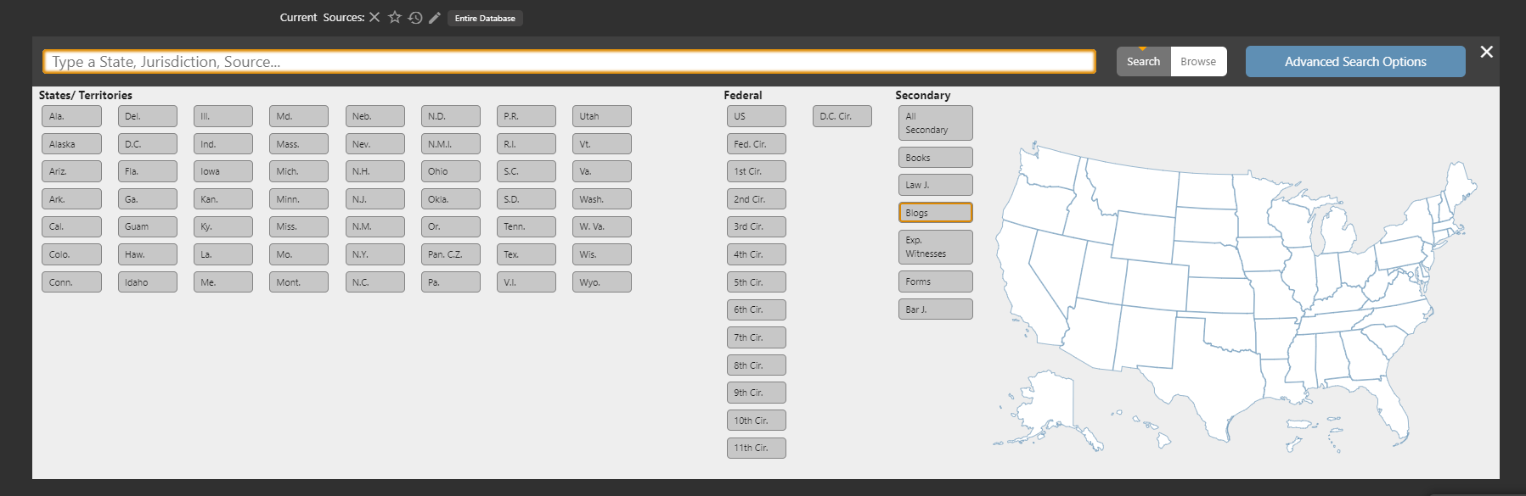
Facebook/LinkedIn/Newsletter: Wanna see what the pros are talking about? Access Lexblog articles through Fastcase 7 for free. Simply click on “Blogs”, search for your favorite topic, and see what all the buzz is about.

January 27, 2020
Tweet: Sometimes you just want to see the instructions. We get it. Check out the Fastcase User Guide. All the info. With Pictures!

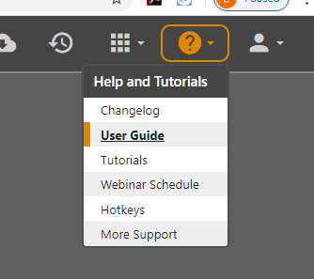

Facebook/LinkedIn/Newsletter: Sometimes you just want to see the instructions. We get it. Check out the Fastcase User Guide. All the info. With Pictures! Just click on the “?” logo, select User Guide, and see step-by-step instructions with pictures.

