Fastcase Partner Marketing

This document contains content you are invited to send out to your members in the next two weeks. You are welcome to use this copy in any manner you want without obtaining our permission. We hereby grant you a non-exclusive right to reproduce, edit, publish, and reuse any material contained within this file. We hope you enjoy this content and find it to be a useful tool. Because this letter is sent to all of our bar association partners, we use the term [Your Bar Here] within our social media bytes so you can insert your organization’s name.

All images are optional additions to your posts. To use, left click on the image to access the hosted content or right click and select “Save as Picture” to download. Please send any suggestions, questions, and comments to Joe Patz Vineyard at joe@fastcase.com.

A proposed timeline is provided, but feel free to deviate as appropriate. Please do not push this copy all at once – this information is intended to be released gradually over the month. Feel free to use and distribute any of these bytes in newsletters, tips, publications, videos, or whatever format you desire. You do not need our permission.

The distribution cadence of our marketing materials will resume to monthly intervals. The next marketing materials will be distributed on August 3.

Important note for all partners defaulted currently to Fastcase 6.

As many know, Fastcase has worked for years to build out our new Fastcase 7 platform. I am thrilled to say, the time is here. We are ready to migrate all of our partners into the new Fastcase 7 platform. If you are already defaulted to Fastcase 7 no action will be needed by you.

If your association's current default is Fastcase 6, I want to be sure you have the date in which your transition is planned. As well as our plan to provide content. We will continue to host more videos/intros to the new platform. A blog post providing detailed descriptions of the platform can be found here: https://www.fastcase.com/blog/transition-to-the-new-fastcase/

Upcoming Fastcase 7 Transition

Phase Timeline
Phase 0 | September 1st
Phase 1 | September 7th
Phase 2 | September 14th
Phase 3 | September 21st

State | Bar Association Name | Switching to FC7
Arkansas | Arkansas Bar Association | In Fastcase 7
California - CLA | California Lawyers Association | In Fastcase 7
Georgia | State Bar of Georgia | In Fastcase 7
Lawyers Mutual |  | In Fastcase 7
Louisiana | Louisiana State Bar Association | In Fastcase 7
Tennessee | Tennessee Bar Association | In Fastcase 7
Utah | Utah State Bar | In Fastcase 7
Washington | Washington State Bar Association | In Fastcase 7
National | American Immigration Lawyers Association | In Fastcase 7
Alabama | Alabama State Bar - Hard Launching on September 1st | Phase 0
NA | Law Library Partners | Phase 0
California - Alameda Co. | Alameda County Bar Association | Phase 1
California - San Fernando Valley | San Fernando Valley Bar Association | Phase 1
District of Columbia | D.C. Bar | Phase 1
Iowa | Iowa State Bar Association | Phase 1
Minnesota | Minnesota State Bar Association | Phase 1
Montana | State Bar of Montana | Phase 1
North Carolina | North Carolina Bar Association | Phase 1
South Carolina | South Carolina Bar | Phase 1
Virginia | Virginia State Bar | Phase 1
West Virginia | West Virginia State Bar | Phase 1
National | Federal Circuit Bar Association | Phase 1
National | National Association of Consumer Bankruptcy Attorneys | Phase 1
National | National Business Institute | Phase 1
National | The National Creditors Bar Association | Phase 1
Florida | The Florida Bar | Phase 2
New York | New York State Bar Association | Phase 2
Texas | State Bar of Texas | Phase 2
Arizona | State Bar of Arizona | Phase 3
Delaware | Delaware State Bar Association | Phase 3
Hawaii | Hawaii State Bar Association | Phase 3
Illinois | Illinois State Bar Association | Phase 3
Maine - York Bar | York Bar Association | Phase 3
Maryland | Maryland State Bar Association | Phase 3
Massachusetts | Massachusetts Bar Association | Phase 3
Mississippi | The Mississippi Bar | Phase 3
Missouri | The Missouri Bar | Phase 3
Nevada | State Bar of Nevada | Phase 3
New Jersey | New Jersey State Bar Association | Phase 3
New Mexico | State Bar of New Mexico | Phase 3
Ohio - Akron | Akron Bar Association | Phase 3
Ohio - Cleveland | Cleveland Metropolitan Bar Association | Phase 3
Ohio - Dayton | Dayton Bar Association | Phase 3
Ohio - Columbus | Columbus Bar Association | Phase 3
Ohio- Toledo | Toledo Bar Association | Phase 3
Oklahoma | Oklahoma Bar Association | Phase 3
Oregon | Oregon State Bar | Phase 3
South Dakota | State Bar of South Dakota | Phase 3
Wisconsin | State Bar of Wisconsin | Phase 3

Tweets

Wednesday, August 5
Starting in September, all @Fastcase users will default to the new Fastcase platform. Register now to join a live walk-through of running searches and accessing content on the new platform to perfect your legal research: tinyurl.com/newfastcase

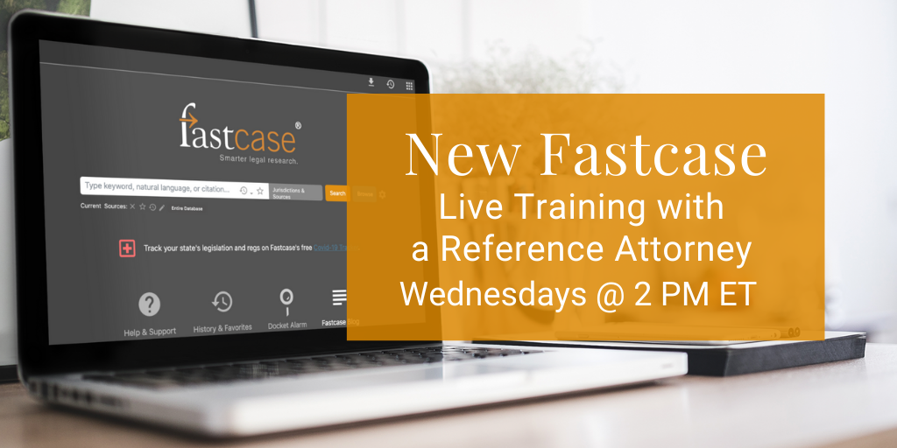

Monday, August 10
The #LeadersInLaw monthly webinar series from @fastcase features interviews with notable attorneys advancing civil rights. Sign up to be notified when August’s session is available for registration: http://tinyurl.com/leadersinlaw

Thursday, August 13 -
Don’t forget to register now to join a live walk-through of running searches and accessing content on the new platform to perfect your legal research: tinyurl.com/newfastcase

Monday, August 17
Supplement your free @fastcase legal research benefit with free legal news from @lawstreetmedia. Subscribe to tech and agriculture feeds for a daily newsletter with stories and links to filings: bit.ly/2Wa9vAX
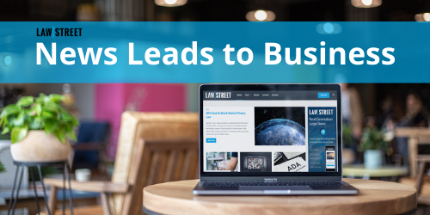

Thursday, August 20 [For Associations in Fastcase 6]

Don’t forget to register now to join a live walk-through of running searches and accessing content on the new platform to perfect your legal research: tinyurl.com/newfastcase

For association note only please do not share. Non-CLE webinar recordings can be made available to any state association CLE team that wishes to offer free on demand content. By utilizing this content on your side, we do ask disclaimer information shared that Fastcase will receive a list of individuals that utilize the content so we can monitor utilization of these webinars and market future content when possible.

Fastcase webinar dates for August
Take advantage of free Fastcase webinars on how to conduct legal research. These webinars are available for CLE credit in many jurisdictions, and a great way to accumulate CLE credit remotely. Click the webinar titles below to sign up for the next four sessions now.

Introduction to Legal Research on Fastcase
Webinar Date: Thursday, August 6, 2020
Webinar Time: 1:00 PM – 2:00 PM Eastern

Data Analytics: Fastcase and Docket Alarm
Webinar Date: Thursday, August 13, 2020
Webinar Time: 1:00 PM – 2:00 PM Eastern

Introduction to Boolean on Fastcase
Webinar Date: Thursday, August 20, 2020
Webinar Time: 1:00 PM – 2:00 PM Eastern

Ethics and Legal Research Featuring Fastcase
Webinar Date: Thursday, August 27, 2020
Webinar Time: 1:00 PM – 2:00 PM Eastern

