Fastcase Partner Marketing

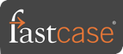

This document contains content you are invited to send out to your members in the next four weeks. You are welcome to use this copy in any manner you want without obtaining our permission. We hereby grant you a non-exclusive right to reproduce, edit, publish, and reuse any material contained within this file. We hope you enjoy this content and find it to be a useful tool. Because this letter is sent to all of our bar association partners, we use the term [Your Bar Here] within our social content so you can insert your organization’s name.

All images are optional additions to your posts. To use, left click on the image to access the hosted content or right click and select “Save as Picture” to download. Please send any suggestions, questions, and comments to Joe Patz Vineyard at joe@fastcase.com.

A proposed timeline is provided, but feel free to deviate as appropriate. Please do not push this copy all at once – this information is intended to be released gradually over the month. Feel free to use and distribute any of these bytes in newsletters, tips, publications, videos, or whatever format you desire. You do not need our permission.

The distribution cadence of our marketing materials will resume to monthly intervals. The next marketing materials will be distributed on or about December 1.

Tweets

Wednesday, November 4 -
The @Fastcase support team is here to help with your legal research reference and technical questions. Contact Fastcase by email, using the LiveChat feature located on http://www.fastcase.com/support/ or by phone to speak with a reference attorney.

Monday, November 9 -

As you type into the search box of @Fastcase 7, type-ahead functionality will suggest the most likely search phrases. You can click on the displayed suggestions to jump right into a document. 💻

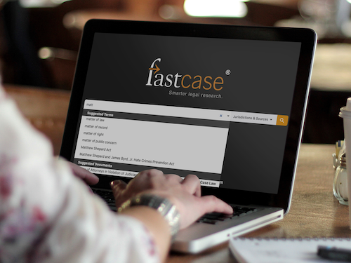

Thursday, November 12
Did you know [insert association] offers @Fastcase legal research as a free member benefit? Login today to start researching. Learn more at [insert association Fastcase page]

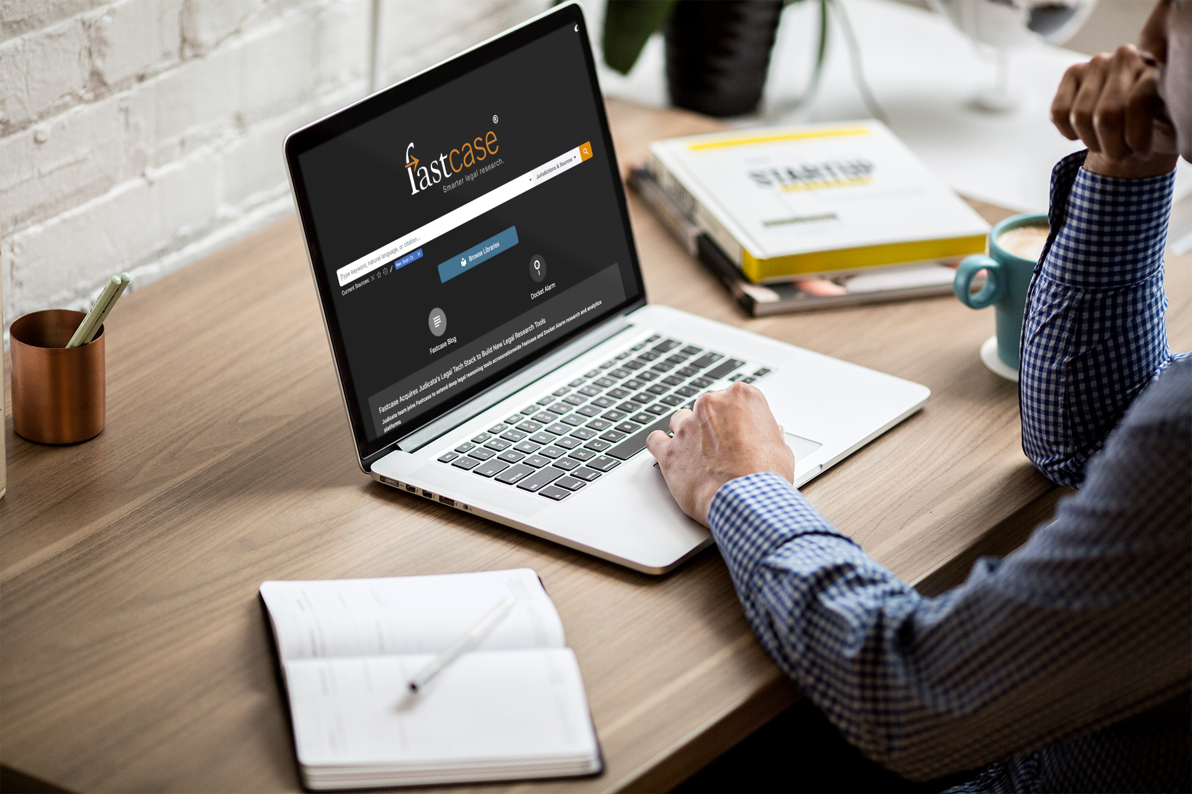

Tuesday, November 17-
Have you checked out @LexBlog in @fastcase 7? Get the latest legal commentary from leading practitioners and experts in their field. You have free LexBlog access with your Fastcase member benefit.

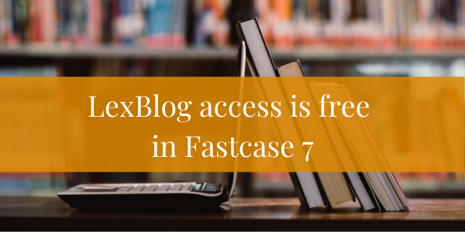

Thursday, November 19
In @Fastcase 7, you can download an entire chapter from a statue with just one click. Simply open the outline for the document and click the download arrow on any chapter.

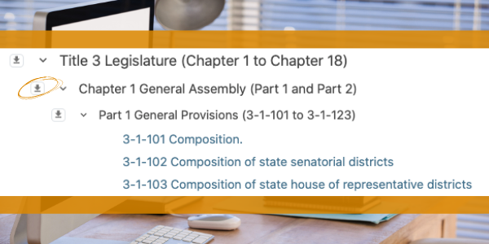

Tuesday, November 24

Free legal news from @lawstreetmedia by @fastcase now includes a selection of articles with embedded analytics. Check out Law Street Media Insights articles here: https://bit.ly/2Tzjn5i #legalnews

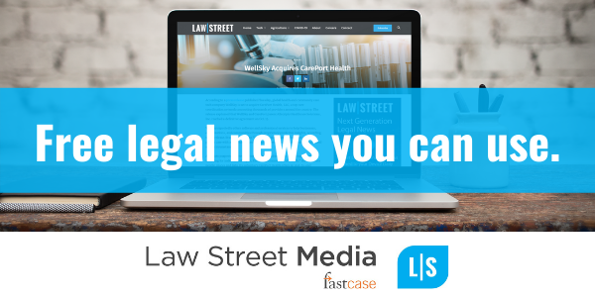

For association note only please do not share. Non-CLE webinar recordings can be made available to any state association CLE team that wishes to offer free on demand content. By utilizing this content on your side, we do ask disclaimer information shared that Fastcase will receive a list of individuals that utilize the content so we can monitor utilization of these webinars and market future content when possible.

Fastcase webinar dates for November

Take advantage of free Fastcase webinars on how to conduct legal research. These webinars are available for CLE credit in many jurisdictions, and a great way to accumulate CLE credit remotely. Click the webinar titles below to sign up for the next four sessions now.

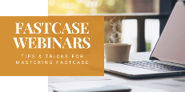

Introduction to Legal Research on Fastcase
Webinar Date: Thursday, November 5, 2020
Webinar Time: 1:00 PM – 2:00 PM Eastern

Data Analytics: Fastcase and Docket Alarm
Webinar Date: Thursday, November 12, 2020
Webinar Time: 1:00 PM – 2:00 PM Eastern

Introduction to Boolean on Fastcase
Webinar Date: Thursday, November 19, 2020
Webinar Time: 1:00 PM – 2:00 PM Eastern

