Fastcase Partner Marketing

This document contains content you are invited to send out to your members in the next two weeks. You are welcome to use this copy in any manner you want without obtaining our permission. We hereby grant you a non-exclusive right to reproduce, edit, publish, and reuse any material contained within this file. We hope you enjoy this content and find it to be a useful tool. Because this letter is sent to all of our bar association partners, we use the term [Your Bar Here] within our social media bytes so you can insert your organization’s name.

All images are optional additions to your posts. To use, left click on the image to access the hosted content or right click and select “Save as Picture” to download. Please send any suggestions, questions, and comments to marketing@fastcase.com.

A proposed timeline is provided, but feel free to deviate as appropriate. Please do not push this copy all at once – this information is intended to be released gradually over the month. Feel free to use and distribute any of these bytes in newsletters, tips, publications, videos, or whatever format you desire. You do not need our permission.

The next marketing materials will be distributed on May 3.

Tweets

Tuesday, April 6 -
@LawStreetMedia is preparing a new series of featured articles, providing analysis from practitioners and other legal thought leaders. Interested in being a part of the first series? Submit your topic proposal here: https://lawstreetmedia.com/viewpoints-submit/

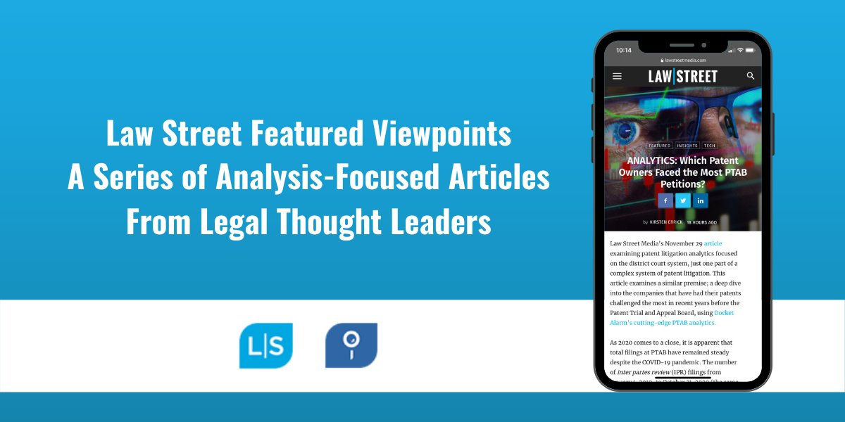

Thursday, April 8 - (this tweet is optional - Webinar is not approved for CLE credit)
April 14 | 2 PM ET join @Fastcase for a conversation on the history, present events, and future of the death penalty. Guests include Judge Russell Canan of the Superior Court of the District of Columbia. Register now: https://register.gotowebinar.com/register/4798770534303755792
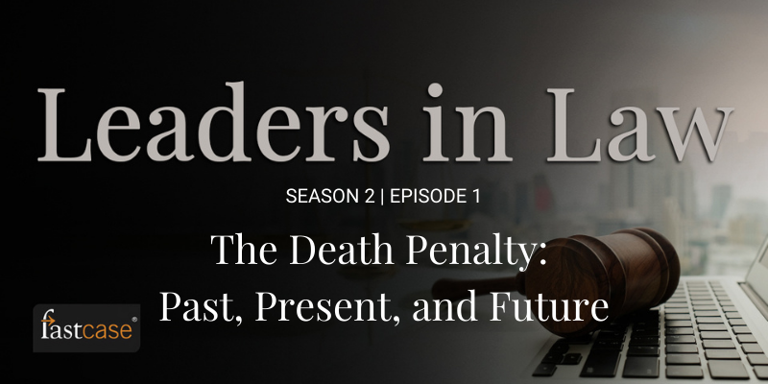

Tuesday, April 13 -

Need to search the same jurisdiction again? With your free access to @fastcase, your jurisdiction history is saved so you can search it again with ease. #legaltech

Click this link to download this gif: https://drive.google.com/file/d/1O9rwz5Yz7AVXWl2Mi7USIiW1ekCZpSrL/view

Thursday, April 15 -

Did you know that as a member of [benefit provider] you can subscribe for free to @fastcase COVID-19 Case Alerts? Subscribe now to stay on top of new civil opinions, breaking news, and analyses of legal issues related to the coronavirus pandemic through the Fastcase 7 app.

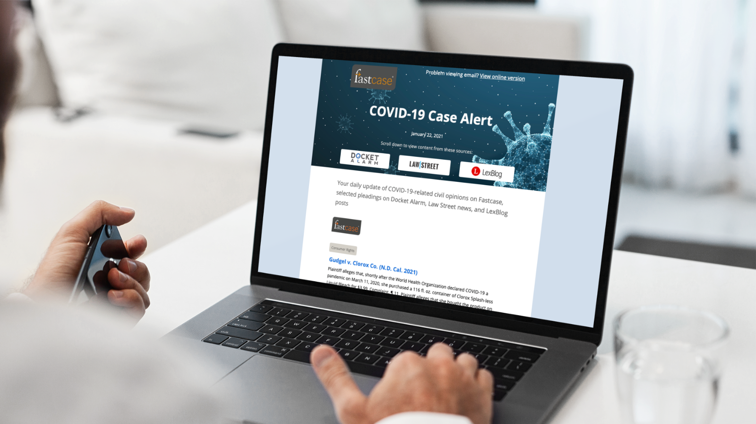
Tuesday, April 20 -

Are you getting the most out of your free access to @fastcase? Check out this walkthrough of Fastcase 7 and learn all the tips and tricks you need to enhance your legal research: https://www.youtube.com/watch?v=X574VjS7dUA&feature=youtu.be

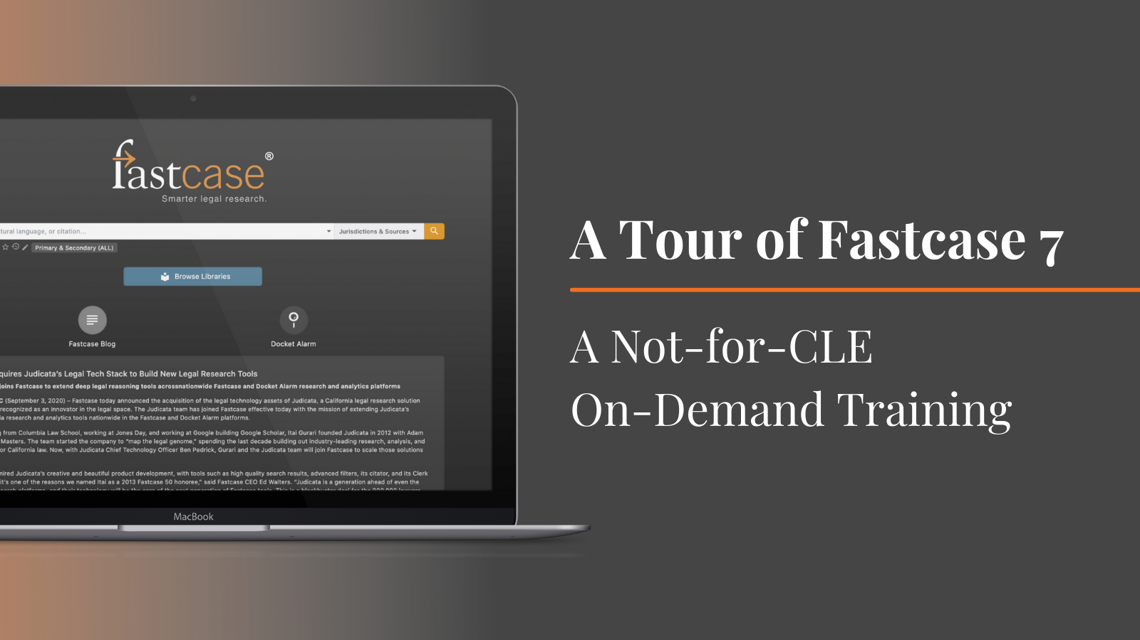

Thursday, April 22 -

Don't forget to check out @fastcase's weekly Thursday webinars 🗓️ Whether you’re a new or experienced user, product experts will help you make sure you are getting the most out of your FREE access to Fastcase legal research. Register here: https://www.fastcase.com/webinars/

Tuesday, April 27 -

Want to hear from leading legal professionals on the latest insights into emerging issues in litigation? Subscribe now to the Emerging Litigation Podcast on iTunes, Spotify, Stitcher or listen on @LawStreetMedia 🎧New episodes every other Tuesday! https://lawstreetmedia.com/emerging-litigation-podcast/

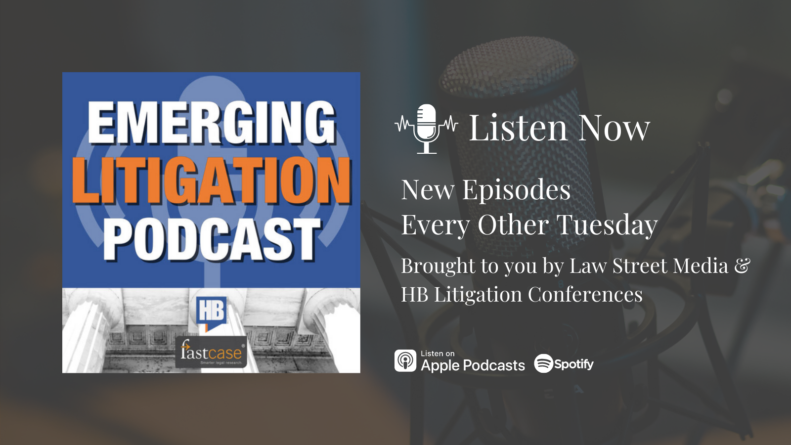

Thursday, April 29 -

The @fastcase support team is here to help with your legal research reference and technical questions. Contact Fastcase by email, using the LiveChat feature located on http://www.fastcase.com/support/ or by phone to speak with a reference attorney.

For association note only please do not share. Non-CLE webinar recordings can be made available to any state association CLE team that wishes to offer free on demand content. By utilizing this content on your side, we do ask for disclaimer information shared that Fastcase will receive a list of individuals that utilize the content so we can monitor utilization of these webinars and market future content when possible.

Specialty Webinars (Non-CLE)
Leaders in Law: The Death Penalty - Past, Present, and Future

Webinar Date: Wednesday, April 14
Webinar Time: 2:00 PM – 3:00 PM ET

Event Placeholder - If Casemaker is working directly with your association to provide a live event, this is the placeholder text to be used

Reminder to register for [event], where @fastcase will be presenting, “[title here]”: [insert registration link]

Upcoming Fastcase Webinars

Introduction to Legal Research on Fastcase
Webinar Date: Thursday, April 1, 2021
Webinar Time: 1:00 PM – 2:00 PM Eastern
Download Handout Here

The Docket Sheet: A Docket Research Primer for the Modern Attorney Featuring Docket Alarm
Webinar Date: Thursday, April 8, 2021
Webinar Time: 1:00 PM – 2:00 PM Eastern
Download Handout Here

Tour of Fastcase 7 (Not for CLE Credit)
Webinar Date: Monday, April 12, 2021 (Offered every other week on Monday. Selected desired time from drop down menu on registration page.)
Webinar Time: 2:00 PM – 3:00 PM Eastern

Introduction to Legal Research on Fastcase
Webinar Date: Thursday, April 15, 2021
Webinar Time: 1:00 PM – 2:00 PM Eastern
Download Handout Here

Introduction to Boolean on Fastcase
Webinar Date: Thursday, April 22, 2021
Webinar Time: 1:00 PM – 2:00 PM Eastern
Download Handout Here

Webinar Graphics - Optional graphics to promote Fastcase webinars

