Fastcase Partner Marketing

This document contains content you are invited to send out to your members in the next two weeks. You are welcome to use this copy in any manner you want without obtaining our permission. We hereby grant you a non-exclusive right to reproduce, edit, publish, and reuse any material contained within this file. We hope you enjoy this content and find it to be a useful tool. Because this letter is sent to all of our bar association partners, we use the term [Your Bar Here] within our social media bytes so you can insert your organization’s name.

All images are optional additions to your posts. To use, left click on the image to access the hosted content or right click and select “Save as Picture” to download. Please send any suggestions, questions, and comments to marketing@fastcase.com.

A proposed timeline is provided, but feel free to deviate as appropriate. Please do not push this copy all at once – this information is intended to be released gradually over the month. Feel free to use and distribute any of these bytes in newsletters, tips, publications, videos, or whatever format you desire. You do not need our permission.

The next marketing materials will be distributed on June 1.

Tweets

Tuesday, May 4 -
The deadline to nominate the most inspiring and noteworthy innovators in law with the Fastcase 50 award is quickly approaching. All lawyers, non-lawyers, techies or non-techies are eligible! Nominate a deserving hero to be part of the annual Fastcase 50: https://bit.ly/3liM6ba

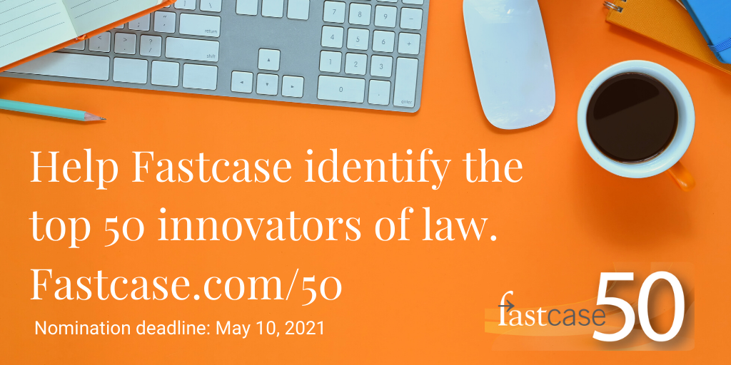

Thursday, May 6 -

Check out the @fastcase Quick Reference Guide and find quick tips on browsing documents, locating cases by party name or citation, and batch-downloading. Access here: tinyurl.com/y5tblxmw

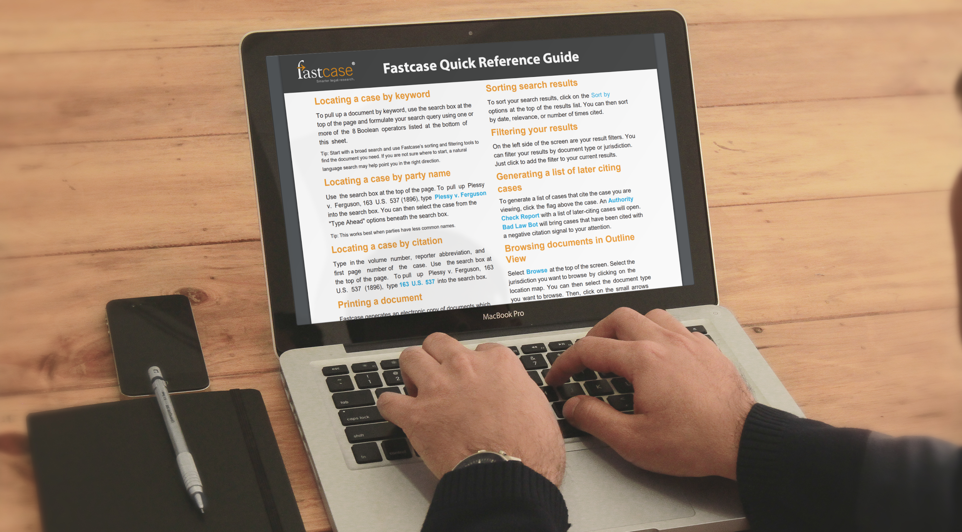
Tuesday, May 11 -

@LawStreetMedia has launched a new series of featured articles, providing analysis from practitioners and other legal thought leaders. Interested in being published? Submit your topic proposal here: https://lawstreetmedia.com/viewpoints-submit/

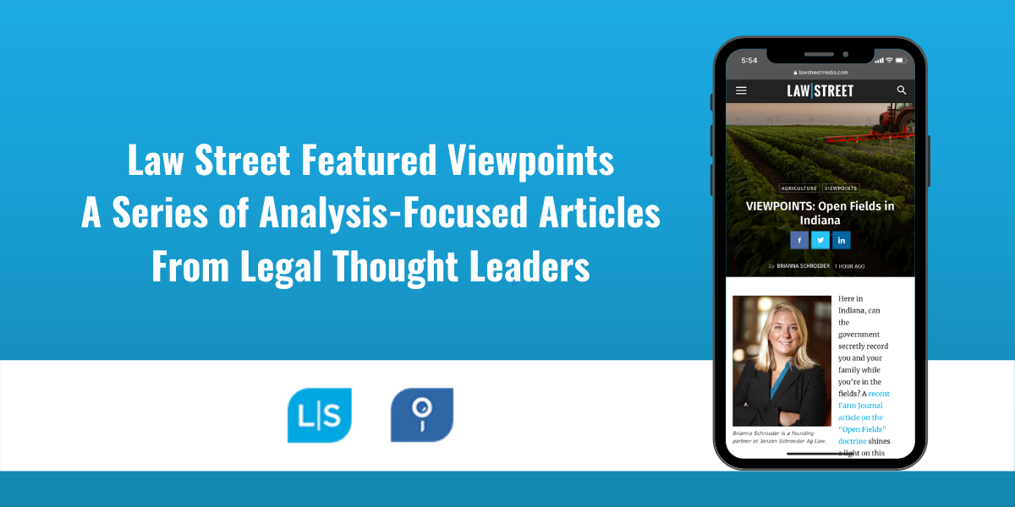

Thursday, May 13 -

Did you know that as a member of [benefit provider] you can subscribe for free to @fastcase COVID-19 Case Alerts? Subscribe now to stay on top of new civil opinions, breaking news, and analyses of legal issues related to the coronavirus pandemic through the Fastcase 7 app.

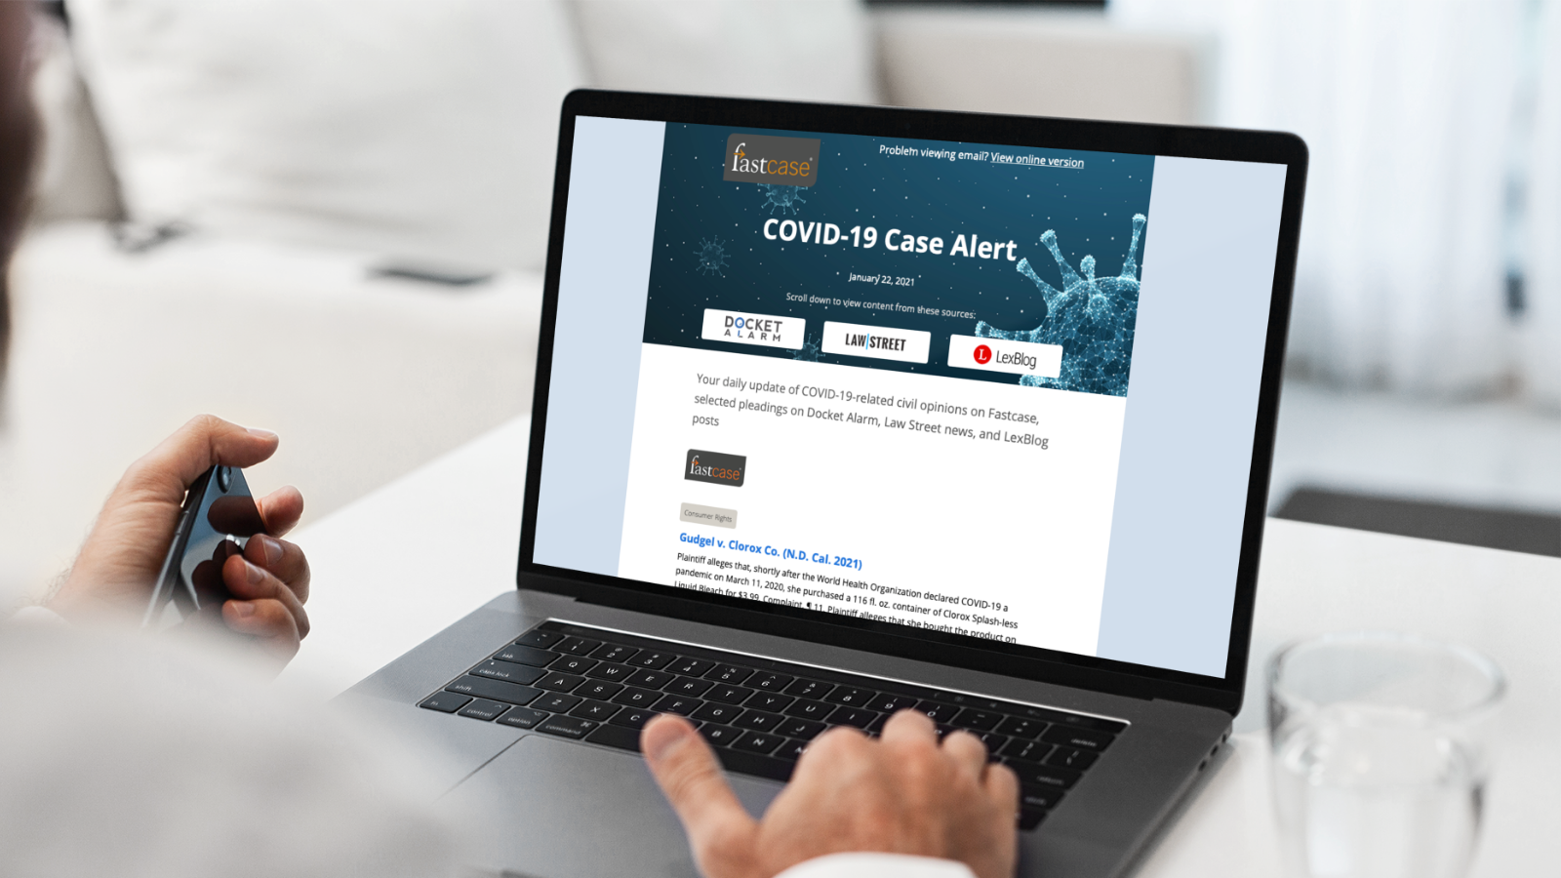
Tuesday, May 18 -

Want to learn more about what @fastcase can do? Check out their pre-recorded video tutorials to explore its powerful search tools on your own time: https://www.fastcase.com/support/

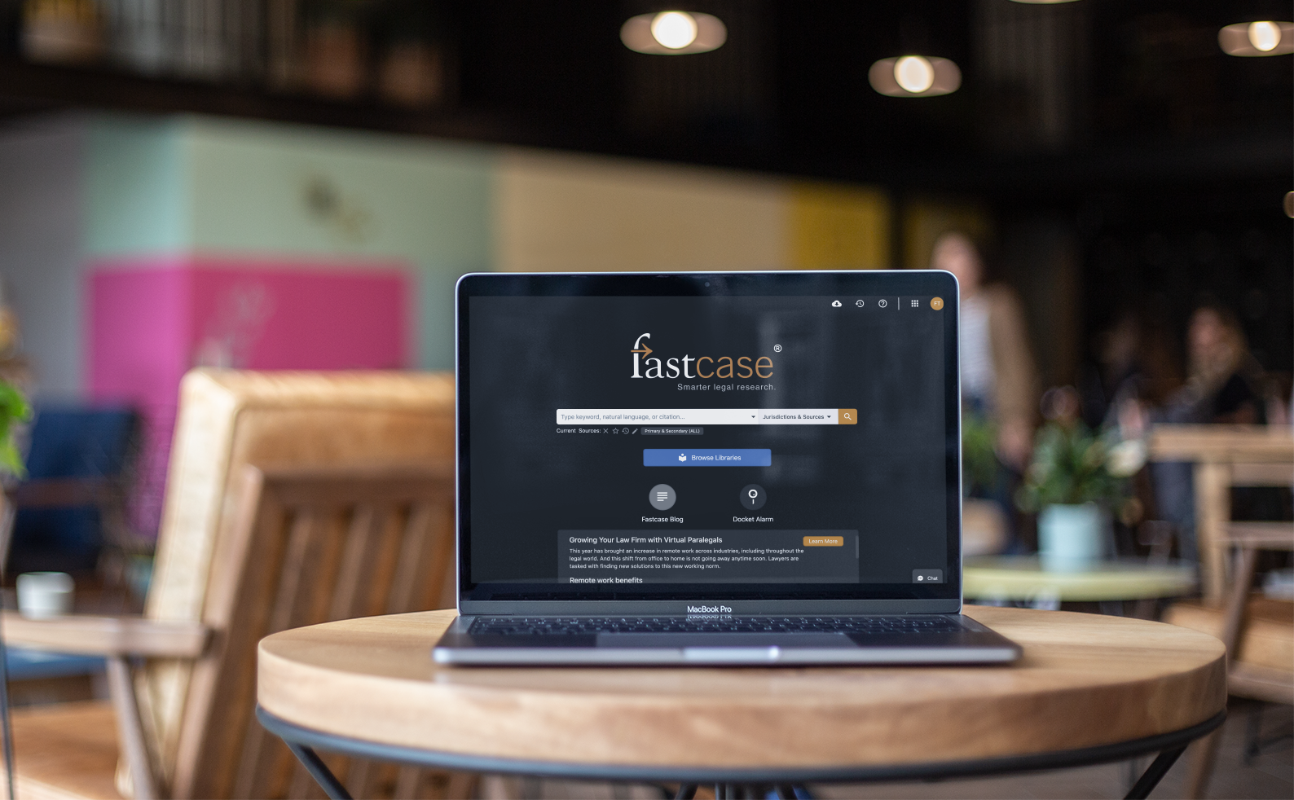

Thursday, May 20 -

Want to hear from leading legal professionals on the latest insights into emerging issues in litigation? Subscribe now to the Emerging Litigation Podcast on iTunes, Spotify, Stitcher or listen on @LawStreetMedia 🎧New episodes every other Tuesday! https://lawstreetmedia.com/emerging-litigation-podcast/

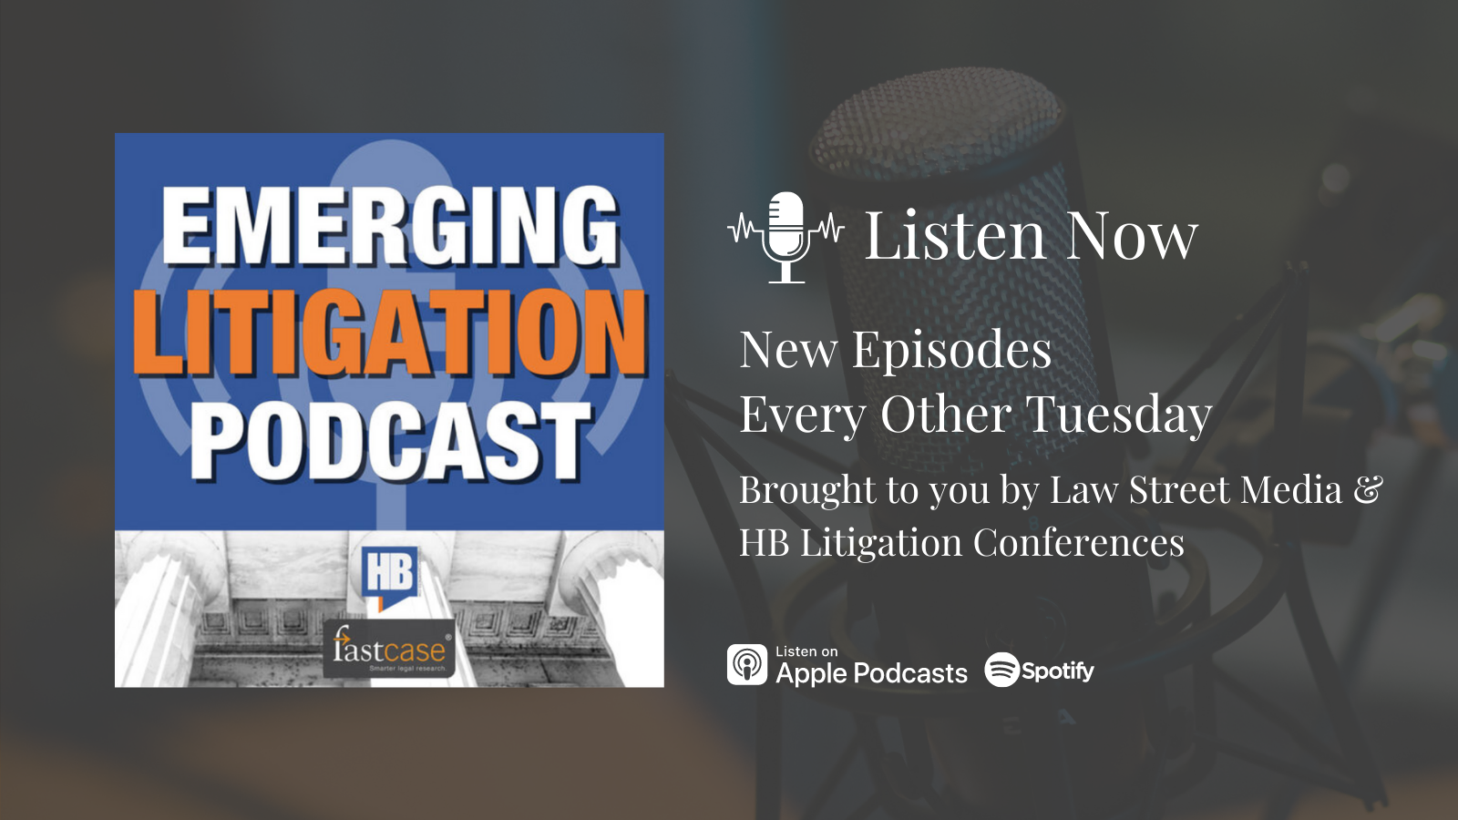
Tuesday, May 25 -

[insert association] offers @Fastcase legal research as a free member benefit! Did you know you can start researching today? Login now and learn more at [insert association Fastcase page]

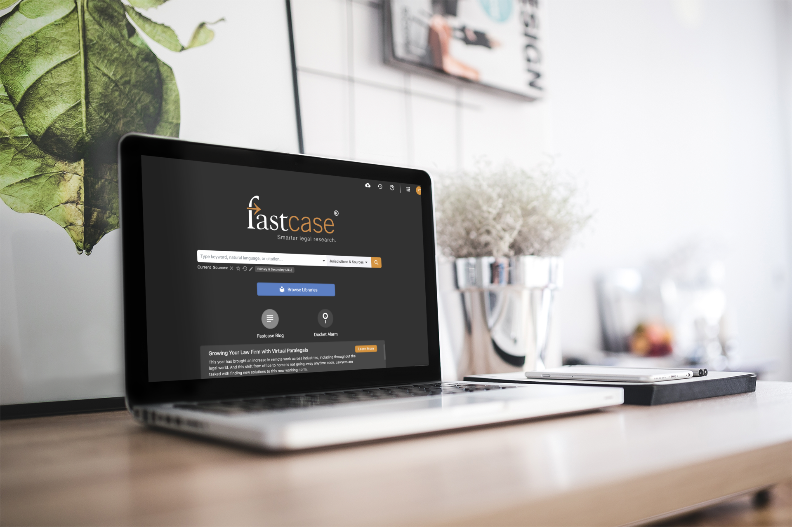

Thursday, May 27 -

Don't forget to check out @fastcase's weekly Thursday webinars 🗓️ Whether you’re a new or experienced user, product experts will help you make sure you are getting the most out of your FREE access to Fastcase legal research. Register here: https://www.fastcase.com/webinars/

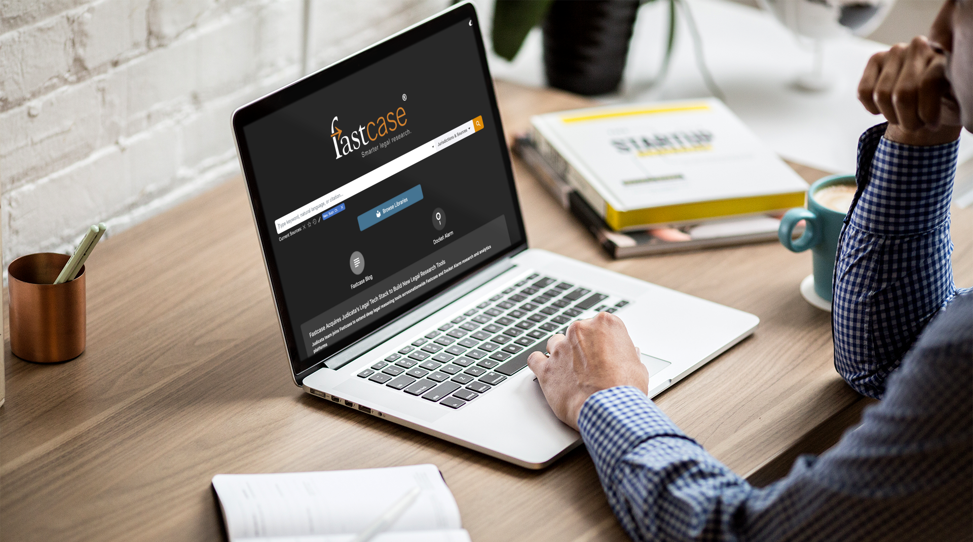
For association note only please do not share. Non-CLE webinar recordings can be made available to any state association CLE team that wishes to offer free on demand content. By utilizing this content on your side, we do ask for disclaimer information shared that Fastcase will receive a list of individuals that utilize the content so we can monitor utilization of these webinars and market future content when possible.

Specialty Webinars (Non-CLE)

Event Placeholder - If Casemaker is working directly with your association to provide a live event, this is the placeholder text to be used

Reminder to register for [event], where @fastcase will be presenting, “[title here]”: [insert registration link]

Upcoming Fastcase Webinars

Introduction to Legal Research on Fastcase
Webinar Date: Thursday, May 6, 2021
Webinar Time: 1:00 PM – 2:00 PM Eastern
Download Handout Here

The Docket Sheet: A Docket Research Primer for the Modern Attorney Featuring Docket Alarm
Webinar Date: Thursday, May 13, 2021
Webinar Time: 1:00 PM – 2:00 PM Eastern
Download Handout Here

Introduction to Legal Research on Fastcase
Webinar Date: Thursday, May 20, 2021
Webinar Time: 1:00 PM – 2:00 PM Eastern
Download Handout Here

Introduction to Boolean on Fastcase
Webinar Date: Thursday, May 27, 2021
Webinar Time: 1:00 PM – 2:00 PM Eastern
Download Handout Here
Webinar Graphics - Optional graphics to promote Fastcase webinars

